# Arts Response Grants

**On this page:**

* What are the City of Port Phillip Arts Response grants?
* Grant streams
* Guidelines and criteria
* Access and support
* Other funding resources and opportunities

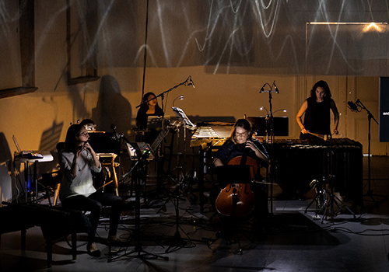

Image: Glitch, Rubiks Collective 2019. Photo Cameron Jamieson

## What are the City of Port Phillip Arts Response grants?

Three streams of small quick response grants have been developed by the City of Port Phillip to support local artists, cultural organisations, and creative groups dealing with the ongoing impact of COVID-19.

Applications to each stream will close at 12 midnight Monday 8 June 2020.

Applicants will be notified of the outcomes in July 2020.

Applicants can apply for up to and between $4,000 and $8,000 depending on the stream and criteria for each stream.

**Auspice information for individual artist applicants**

The City of Port Phillip will require successful applicants who are individual artists or individuals applying for a small unincorporated collective or group project to engage an auspice organisation to assist in managing the grant. Read this document to find out how to work with an auspice organisation

For the purpose of the Arts response grants, the key auspice organisations will be:

* Auspicious Arts Projects (for First Peoples and Response grants streams)
* Arts Access Victoria (for THRIVE local grants)
* Auspice organisation fee for this series of grants

Applicants should include in their budgets an auspice administration fee of 5% (Auspicious Arts) or 10% (Arts Access) of the total grant request.

**Project activity and acquittal reporting dates**

Project activity can occur between August 2020 and December 2021.

Applicants will be required to submit a grant acquittal document eight weeks from completion

## Grant streams

The three streams are:

* THRIVE local grants for disability and deaf arts groups or for individual artists who live or work in Port Phillip. Up to $4,000
* First Peoples grants for First Nations artists who live and work in City of Port Phillip or Boon Wurrung artists living in Victoria to produce online work. Up to $4,000
* Arts Response grants – a general grant stream for all artists who live or work in the City of Port Phillip or for incorporated not for profit organisations or groups based in Port Phillip. Up to $4,000 for individuals and up to $8,000 for group or organisational projects.

Proposals can relate to all artforms, including visual arts, performance, dance, writing and spoken word, cross-disciplinary work, heritage projects, music, design, multimedia and film, or electronic and digital media, or artist in community projects.

**The grants aim to support:**

* research and development of new work
* production of new, digitally enabled or online work
* promotion of existing work online (increasing capacity and can include purchase of digital equipment)
* arts engagement activities developed online which support and engage diverse communities and which connect to longer-term new or existing face-to-face programs
* explore capacity building opportunities including mentoring, partnership or collaborative development
* development of work that engages with the wider Port Phillip community, including children, vulnerable groups, and traders

## Guidelines and criteria

Read the Guidelines and Criteria document for your chosen stream in the section below before applying

**How to apply**

**THRIVE local grants**

2020 THRIVE local Guidelines and Criteria (DOCX 34 KB)

2020 THRIVE local Guidelines and Criteria (PDF 421 KB) print version

Go to the Word version 2020 THRIVE local application form (DOCX 46KB) to submit your idea.

You can download and print a version of the 2020 THRIVE local application form here (PDF 368KB)

You can submit your application in three ways:

* by email
* in hard copy by postal application
* by video. This must be in combination with a hard copy or email budget and support material.

You can discuss your project idea or eligibility with the Community Cultural Development Officer before submitting an application on 0409 047 849 or thrive@portphillip.vic.gov.au

**First Peoples grants**

2020 First Peoples grants Guidelines and Criteria (DOCX 655 KB)

2020 First Peoples grants Guidelines and Criteria (PDF 685 KB) print version

You can preview and apply here through a link to the online application form through Smartygrants

For tips on how to log in, preview and navigate through your application form, read the Help Guide for Applicants

To discuss you project idea, eligibility or for any other queries contact Jarra Steel, Indigenous Arts Officer on 0403 448 697or email boonatung@portphillip.vic.gov.au

**Response grants**

2020 Response grants Guidelines and Criteria (DOCX 656 KB)

2020 Response grants Guidelines and Criteria (PDF 543 KB)

You can preview and apply here through a link to the online application form through Smartygrants

For tips on how to log in, preview and navigate through your application form, read the Help Guide for Applicants

To discuss you project idea, eligibility or for any other queries contact Sharyn Dawson, Arts Development Officer on 0466 933 057 or email cdf@portphillip.vic.gov.au

## Access and support information

For general Council information about the National Relay Service, language translation and Auslan translation services see the Accessibility page.

For Metro Access support contact 03 9209 6829.

## Other funding resources and opportunities

Other City of Port Phillip grants via Funds, Grants and Subsidies

Art and Soul - Creative and Prosperous City Strategy

Council Plan 2017-27

Reconciliation Action Plan

More information

Contact Us or use Online Services to ask us a question, request information or give us feedback online.

Links to City of Port Phillip Online Services website for online transactions.