COVID-19 Community Recovery Quick Response Grant Program

2021 Guidelines

Contents

COVID-19 Community Recovery Quick Response Grant Program 1

City of Port Phillip COVID-19 Community Recovery Quick Response Grant Program Guidelines 2021 3

Acknowledgment of country 3

Introduction to program 3

Program Objectives 3

About COVID-19 Community Recovery Quick Response Grants Program 4

Eligibility 4

What can be funded? 4

What can’t be funded (exclusions)? 4

Assessment Process 5

Assessment Criteria 5

Support Documentation Required 6

Support Provided by Council 6

Funding Principles 6

Access and Inclusion 6

Ensuring a child safe City of Port Phillip 7

Sustainability 7

Lobbying 8

Appendix A – Definitions 8

Appendix B – City of Port Phillip Map 10

Appendix C – Grant Terms and Conditions 10

# City of Port Phillip COVID-19 Community Recovery Quick Response Grant Program Guidelines 2021

### Acknowledgment of country

Council respectfully acknowledges the Yaluk-ut Weelam Clan of the Boon Wurrung. We pay our respect to their Elders, both past, present and emerging. We acknowledge and uphold their continuing relationship to this land

### Introduction to program

The City of Port Phillip recognises that its Community Grants Program, Subsidy Schemes and Donations provide a strategic opportunity to work in partnership with community groups, organisations and individuals, to strengthen community capacity and create and promote a beautiful, liveable, caring, inviting, bold and real City of Port Philip.

The COVID-19 Community Recovery Quick Response Grants Program is an extension of Council’s Community Grants Program and aligned with [Council’s Community Funding Policy](http://www.portphillip.vic.gov.au/community-funding-policy.htm).

This program provides a one-off funding opportunity to support service providers and community groups respond to:

* community members, and in particular our most vulnerable and socially disconnected residents, who have been affected by the COVID-19 pandemic and their access to participate in community life.
* and address funding gaps that may have arisen from the change to annual Community Grants delivery timeframes.

Program Objectives

The City of Port Phillip COVID-19 Community Recovery Quick Response Grants Program aims to:

* Direct support to community groups that connect with vulnerable or socially disconnected residents who have been most impacted by COVID to facilitate their on-going recovery.
* Enable service providers to promote or remove barriers to participation for socially isolated and vulnerable community members.
* Address funding gaps arising from the change to Community Grants delivery timeframes, for programs that have historically received recurrent funding.

### About COVID-19 Community Recovery Quick Response Grants Program

* Eligible applicants can submit one application within the COVID-19 Community Recovery Quick Response Grants Program. However, an auspicing organisation is permitted to sponsor multiple organisations.
* A total funding budget of $17,900 is available
* Maximum funding per application is $2,000.
* The COVID-19 Community Recover Quick Response Grants Program will open **Monday 9am 22 March and close 4pm on Friday 23 April.**
* The application and reporting processes have been streamlined to make it easy and quick for eligible organisations to access these funds.
* Applicants will be notified of the funding decision within four (4) weeks of this grant round closing.

### Eligibility

To be eligible for a COVID-19 Community Recovery Quick Response Grant Program the applicant must:

* Be deemed to be non-profit as classified by the Australian Taxation Office (section 103A (2) (c) of the income Tax Assessment Act 1936 **or**
* Be a ‘Not-for-Profit’ community group, organisation or club that is incorporated under the Associations Incorporation Act **or**
* Supported by an Auspice Incorporated Association that meets the same requirements <https://www.legislation.gov.au/Details/C2013C00040>.
* Provide an ABN or an Auspice Organisation ABN.
* Have their own Public Liability Insurance or an Auspice Organisation Public Liability Insurance with a minimum of $20 Million.
* Have complied with all terms and conditions including the submission of a satisfactory acquittal report for all previous City of Port Phillip Grants.
* Be located within, or offer projects within, the City of Port Phillip municipality.
* Be able to demonstrate financial viability.

### What can be funded?

The following will be considered for funding, but is not an exhaustive list:

* Building community resilience
* Bridging isolation and building connections (social support)
* Other emerging pandemic recovery needs in line with funding priorities
* Continuity of previously recurrent Community Grant programs (gap funding due to change in community grant programs base on calendar year).

### What can’t be funded (exclusions)?

The following are not eligible for funding in this grant round:

* Items that are part of an organisation’s core business or normal operating expenses e.g. insurances (such as public liability), utilities, rental of business premises etc.
* State-wide projects.
* Projects that do not align with Council’s priority outcomes as identified in the Council Plan 2017-27.
* Projects that are the funding responsibility of other levels of government.
* Projects that have already started or have been completed.
* Private profit-making organisations.

### Assessment Process

We ensure our grant processes are transparent and fair.

* All applications submitted undergo an eligibility check. Applications that do not meet eligibility criteria will not proceed for further assessment and applicants notified by email.
* Throughout each stage of the assessment process any conflicts of interests are declared and addressed.
* An assessment panel will assess each eligible application objectively against the assessment criteria listed in these guidelines.
* All applicants are notified by email of the application outcome.

### Assessment Criteria

The COVID-19 Community Recovery Quick Response Assessment Panel will assess each eligible application objectively against the following assessment criteria:

#### Community Need (weighting 40 per cent)

* Has a need for the program been clearly demonstrated?
* How effectively will the program meet this need?
* Has a need for gap funding clearly been demonstrated?

#### Benefit to Target Groups (weighting 30 per cent)

* Who are the participants? Projects that can show evidence of servicing the most vulnerable experiencing greatest disadvantage or impact from COVID-19 will be considered a priority.
* How will the target group be negatively impacted if the recurrent program does not receive gap funding?
* What benefits will the program deliver to the target group/s

#### Planning & Management (weighting 30 per cent)

* Does the organisation have the necessary resources and experience to successfully manage the program?
* Does the budget reflect value for money?
* Is there evidence of in-kind contribution?
* Have economic and environmental sustainability initiatives been considered in the project design and implementation?

### Support Documentation Required

#### Incorporation

Applicants must be incorporated or hold another legal entity status. Incorporation is the most common way to provide a community group status as a legal entity.

If you are not incorporated and would like to become incorporated, you may contact the Office of Consumer Affairs Victoria on 1300 558 181 or visit the [webpage](https://www.consumer.vic.gov.au/) for more information (<https://www.consumer.vic.gov.au/>).

If your group is not incorporated and does not wish or is unable to become incorporated, you may apply through an auspice organisation.

#### Auspice organisation agreement letter

If your application requires an auspice organisation you must submit a letter confirming from the auspice organisation confirming the agreement.

#### Public and Products Liability Insurance

City of Port Phillip requires applicants to hold current Public and Products Liability Insurance to protect themselves against legal liability for third party’s injury, death and/or damage to property caused by an occurrence in connection with the applicant’s activities. This is proven by providing a valid Certificate of Currency for Public Liability Insurance for 20 million.

### Support Provided by Council

|  |  |
| --- | --- |
| **COVD-19 Community Recovery Quick Response Grant Program Information Sessions** | **Event Details** |
| Session 1 | Thursday 25 March 2.00pm -3.00pm  Online  [Register here](https://www.trybooking.com/BPXMB) |
| Session 2 | Tuesday 30 March 1.30 – 2.30pm  Online  [Register here](https://www.trybooking.com/BPXMB) |

### Funding Principles

| Funding Principles | Funding Principles Example |
| --- | --- |
| Child Safe Standards | Meet obligations in relation to keeping children and young people safe |
| Inclusion & Accessibility | Be free from discrimination and enable equitable participation for all community members |
| Equity | Address disadvantage and offer equal opportunity to all by recognising the individual needs of different community members |
| Responsiveness | Consult with participants and service users to respond to community needs. |
| Efficiency & Effectiveness | Maximise use of community and council resources to achieve project goals. |
| Accountability | Maintain transparent governance and reporting processes. |
| Sustainability | Model environmental, social and economic sustainable practice. |

### Access and Inclusion

Interpreters for Auslan and languages other than English are available upon request. If you have any access or support requirements to enable equitable participation in this program, please contact Metro Access Project Officer on 03 9209 6777 or [Kelly.armstrong@portphillip.vic.gov.au](mailto:Kelly.armstrong@portphillip.vic.gov.au)

Council has also provided an Accessibility and Disability Inclusion Fact Sheet to support applicants ensure that their projects are inclusive for all participants.

### Ensuring a child safe City of Port Phillip

The City of Port Phillip has zero tolerance for child abuse, and we are a committed Child Safe organisation. Our commitment is to ensure that a culture of child safety is embedded across our community to safeguard every child and young person accessing City of Port Phillip.[1]

All grant applications that work directly with children and young people are required to comply with legislation and regulations relating to child safety including, but not limited to, the Working with Children Act 2005 and the Working with Children Regulations 2016 and the [Victorian Child Safe Standards (CSS)](http://intranet.portphillip.vic.gov.au/child-safe-standards.htm)

### Sustainability

The City of Port Phillip has committed to improving sustainability and reducing waste through its strategies, [Act and Adapt and Don't Waste It!](http://www.portphillip.vic.gov.au/Dont-Waste-It.htm)Applicants are advised to avoid the following:

* Balloons
* Single use plastic bags and straws
* Single use crockery and cutlery that cannot be recycled

Applicants are encouraged to consider how they can reduce their impact on the environment by implementing the following:

* Avoiding the use of disposable decorations
* Reducing power consumption
* Utilising e-ticketing
* Promoting public transport, walking and cycling
* Sharing resources with other organisations or project supporters
* Washing crockery and cutlery rather than using disposable items
* Encouraging reusable coffee cups
* Providing drinking water to reduce the use of plastic bottles
* Composting organic waste

For advice about making your event more sustainable, contact Lisa Paton, City of Port Phillip Sustainable Programs, on phone 03 8563 7734 or email [Lisa.Paton@portphillip.vic.gov.au](mailto:Lisa.Paton@portphillip.vic.gov.au)

### Lobbying

Canvassing or lobbying of councillors, employees of the City of Port Phillip or assessment panel members in relation to any grant, subsidy and sponsorship applications is prohibited.

### Appendix A – Definitions

**ABN (Australian Business Number):** The Australian Business Number is a number used to identify a business or organisation for tax and Australian Government purposes. An ABN for the organisation or for the Auspice organisation must be provided in the grant application.

**Auspice:** Any legally constituted body may act as an auspice organisation to partner with and/or apply for or manage funding on behalf of another non-incorporated organisation or individual. If the funding application is successful, the auspice organisation will receive and manage the funds for the applicant to deliver the funded project or activities. The auspice organisation is responsible for the effective acquittal of the grant.

**Acquittal Report:** An acquittal report ensures that grant recipients have administered grant funds responsibly and in line with the terms and conditions of the Funding Agreement. An acquittal report usually consists of a written report that summarises project outcomes in relation to project objectives. It also provides a financial statement detailing how the funds were spent. All acquittal reports are summarised and presented to Council one month after the due date. Organisations that do not submit their acquittal report will be listed and may not be eligible for further funding from the City of Port Phillip.

**Community:** For the purposes of the Community Grants, ‘community’ refers to people living, working, visiting and studying within the City of Port Phillip.

**Community Grants Assessment Panel:** City of Port Phillip has two Community Grant Assessment Panels responsible for assessing Community Grant Applications. Each Panel consists of two Community Representatives, a Councillor and a Council Officer. Care is taken to ensure that representatives do not have a conflict of interest in assessing and recommending Grants for funding.

**Conflict of Interest:** A conflict of interest occurs if a member of the grant assessment panel has something to personally gain from the grant application. It also extends to providing family and close friends with preference.

**Council:** The City of Port Phillip is defined as a geographical area and also the entity which has the authority to make decisions on behalf of the City of Port Phillip.

**Funding Deed:** A Funding Deed is a formal document stating the purpose of the funding, the financial amount, and the conditions attached to the grant. It also defines the rights and responsibilities of the grant recipient and Council. Once signed, recipients are under a legal obligation to comply with the stated terms and conditions. A Funding Deed will be issued to successful applicants for amounts over $2000.

**Grant:** A grant is a sum of money awarded to an organisation for a specified purpose.

**GST (Goods and Services Tax):** Organisations are strongly encouraged to establish their responsibilities in relation to their GST status and indicate on the application form what that status is. Successful organisations with an ABN and registered for GST will receive a Recipient Created Tax Invoice, for their grant, plus 10% GST. Successful organisations with an ABN and not registered for GST will not receive a Recipient Created Tax Invoice or 10% GST for their grant. These organisations will receive only their grant amount.

**In-kind Contributions:** An in-kind contribution is the ‘noncash’ contribution made by the applicant that can be allocated a financial value, i.e. volunteer services. Applications with in-kind contribution will be viewed favourably.

**Incorporated Organisation:** An organisation that is a legal entity and has a legal structure. The organisation must be registered with Consumer Affairs Victoria. For more information please contact Consumer Affairs Victoria or phone 1300 558 181

**Non-compliant:** An applicant (this includes organisation and/or individual) may be deemed non-compliant in the circumstances that the recipient;

* failed to meet terms and conditions of funding deed
* is insolvent
* is under legal investigation
* failed to lodge a satisfactory acquittal (a satisfactory acquittal demonstrates that the selection criteria of the program were met, and the financial expenditure of the project was spent appropriately and/or unspent funds returned to Council)
* did not complete the project and failed to lodge an acquittal
* completed the project and failed to lodge an acquittal

**Not for Profit (NFP) Organisation:** An NFP is an organisation that does not distribute any profit to an individual, its members and or shareholders. Any profit from the organisation will be directed back into the organisation and its activities.

**Objectives / Aims:** An objective/ aim states the overall goals of the project.

**Outcomes:** Outcomes describe the specific results of the project.

**Project Status Report:** An online Project Status Report must be submitted if the Acquittal Report has not been submitted by 06 March 2020.

**Project Variation Report:** A Project Variation Report is to be submitted ONLY if there is to be a substantial variation or change to the project from the initial project application. Funded organisations wishing to submit a Project Variation Report must first contact the Community Grants and Funding Officer on 9209 6694 or [grants@portphillip.vic.gov.au](mailto:grants@portphillip.vic.gov.au)

### Appendix B – City of Port Phillip Map

If you would like to access a digital map of Port Phillip, please view [here](http://maps.portphillip.vic.gov.au/IntraMaps90/ApplicationEngine/frontend/mapbuilder/default.htm?configId=3b15d530-b92a-4d61-9b6f-099749b47934&liteConfigId=e9486dde-8a76-4a71-b16d-ed4e36384c65&title=UG9ydCBQaGlsbGlwIEFjY2VzcyBNYXA=&)

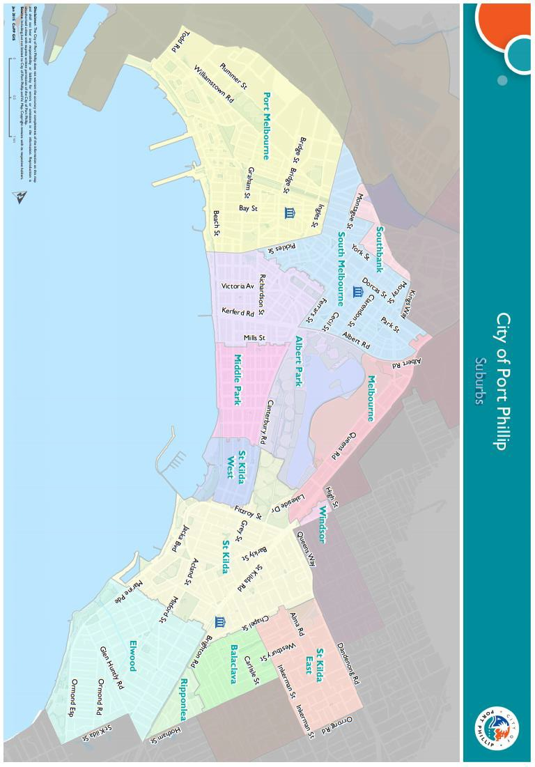

### Appendix C – Grant Terms and Conditions

* If your application is successful you will be required to sign and return the Conditions of Funding Agreement.
* Funded organisations must provide a Project Acquittal Report 4 weeks after completion of the project or before December 2021 by which time all projects should be completed unless otherwise approved in writing by Council. All reports are to be submitted online via <https://portphillip.smartygrants.com.au/>.
* Organisation’s holding a launch or event for the project for which they have been funded and are planning to invite the Mayor/Councillors and/or Council Officers, are required to ensure their invitation is sent at least 4 weeks prior to the event. The relevant Council officer must be notified of this invitation.
* Funded organisations are required to acknowledge the City of Port Phillip in all promotional or publicity material for the funded project. The presentation of the logo should match the involvement and relative importance Council had in the project or activity. A jpg and gif format logo along with City of Port Phillip’s style guide will be provided with the notification letter to successful applicants.
* Funding from the COVID 19 Community Quick Response Recovery Program 2021 requires compliance with specific conditions prior to payment and verification of ABN and GST status.
* The funded organisation must comply with all relevant laws and conditions. Significant State and Commonwealth legislation includes:
  + - * Carer Recognition Act 2012
      * Consumer Affairs Victoria
      * Charter of Human Rights and Responsibilities Act 2006
      * Child Safe Standards
      * Disability Discrimination Act 1992
      * Equal Opportunity Act 1995
      * Fair Work Act 2009
      * Privacy and Data Protection Act 2014
      * Public Liability Insurance
      * Racial and Religious Tolerance Act 2001
      * Child Safe Standards
      * Victorian Disability Act 2006
      * Volunteer Personal Accident Insurance
      * WorkSafe Victoria

1. Full web link to Council’s Child Safe Standards: <http://www.portphillip.vic.gov.au/child-safe-standards.htm>