

PROPOSED DISCONTINUANCE AND SALE OF ROAD ADJOINING 182-192 & 200 CLARENDON STREET, SOUTH MELBOURNE

PUBLIC NOTICE INVITING SUBMISSIONS UNDER SECTION 223

Port Phillip City Council (“Council”), gives notice under section 206 and clause 3 of Schedule 10 of the Local Government Act 1989 (“1989 Act”) and section 114 of the Local Government Act 2020 that Council proposes to discontinue part of the road adjoining the property at 182-192 & 200 Clarendon Street, South Melbourne, being the land remaining in Crown Grant Volume 5106 Folio 1853 and being part of Crown Allotment 9, Section 2, Town and Parish of Melbourne South), as shown hatched on the plan below, and to sell that land to the owner of 182-192 Clarendon Street, South Melbourne VIC 3205 and 200 Clarendon Street, South Melbourne VIC 3205.

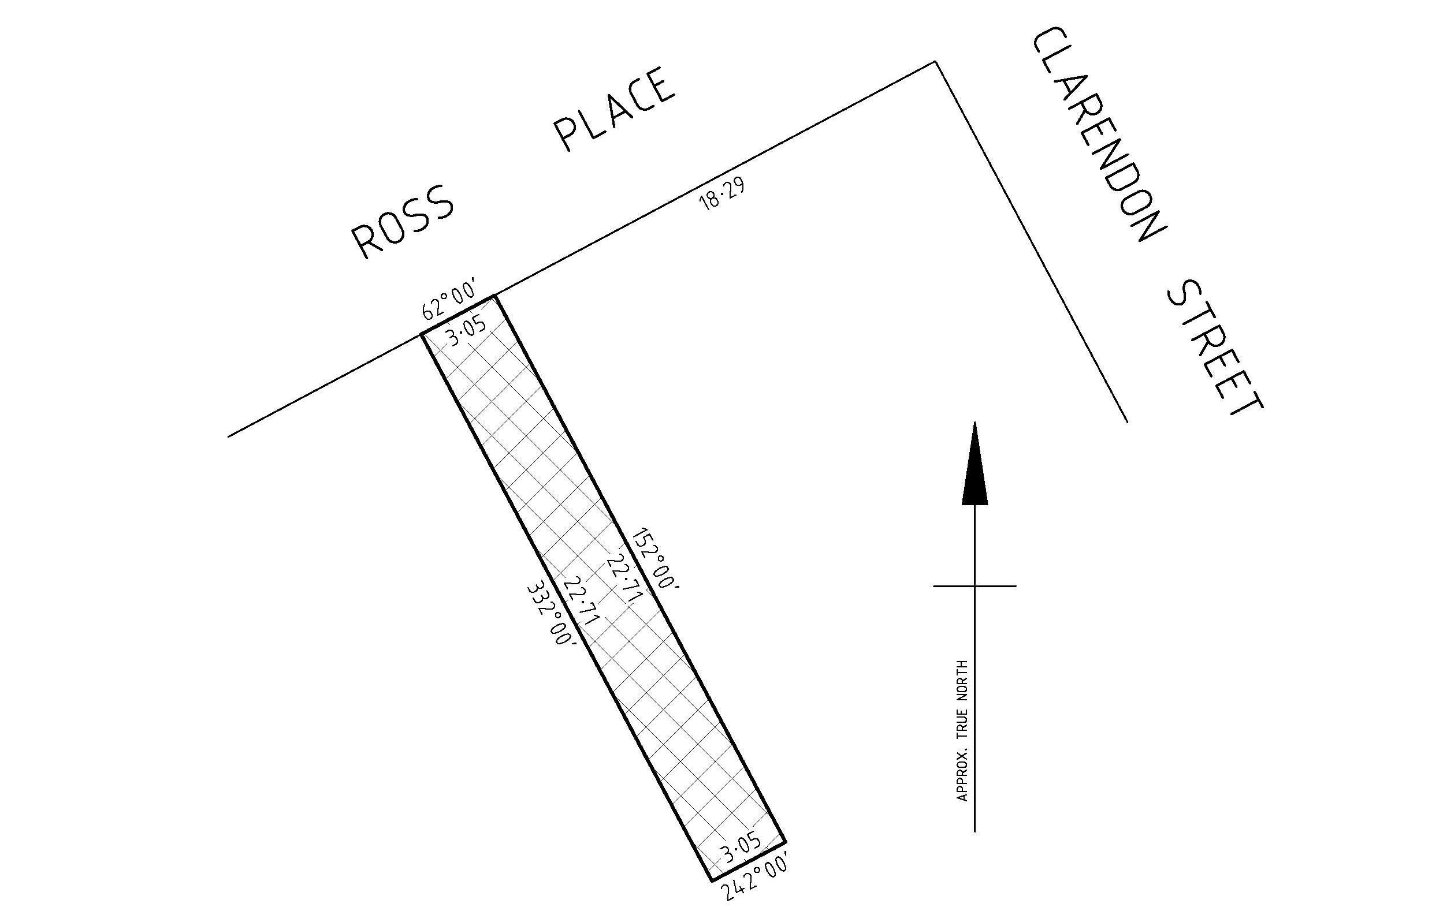

Further information regarding the proposal can be obtained from Bridgette Kennedy (phone: 03 8563 7885).

Any person may make a submission on the proposal. Any person wishing to make a submission must do so in writing by Friday 13 October 2023.

Submissions should be submitted via Council’s website or addressed to Team Leader Property Operations and posted to Port Phillip City Council, Private Bag 3, St Kilda, Victoria 3182. Submissions can also be hand delivered to 99A Carlisle Street, St Kilda 3182.

All submissions will be considered in accordance with section 223 of the 1989 Act. No further community consultation process will be undertaken.

Any person making a submission is entitled to request in the submission that the person wishes to appear in person, or to be represented by a person specified in the submission, at a meeting to be heard in support of that submission.

Any person requesting to appear in person or to be represented by a person specified in his or her submission will be notified of the day, time and place of the meeting of the Council or of a committee determined by the Council to hear submissions.

Following consideration of submissions, Council may resolve not to discontinue the road or to discontinue the road and either sell the land from that road or retain the land.

Chris Carroll
Chief Executive Officer

