

**PROPOSED DISCONTINUANCE AND SALE OF ROAD ADJOINING THE PROPERTIES AT 3-5, 7, 9 and 15 Fitzroy Street, St Kilda VIC 3182**

**PUBLIC NOTICE INVITING SUBMISSIONS UNDER SECTION 223**

Port Phillip City Council (“**Council**”), gives notice under section 206 and clause 3 of Schedule 10 of the *Local Government Act 1989* (“**1989** **Act**”) and section 114 of the *Local Government Act 2020* that Council proposes to discontinue the road adjoining the properties at 3-5, 7, 9 and 15 Fitzroy Street, St Kilda VIC 3182, being the land contained in certificate of title volume 2591 folio 074 and as shown hatchedon the plan below, and to sell that land to the owner of the properties at3-5, 7, 9 and 15 Fitzroy Street, St Kilda VIC 3182.

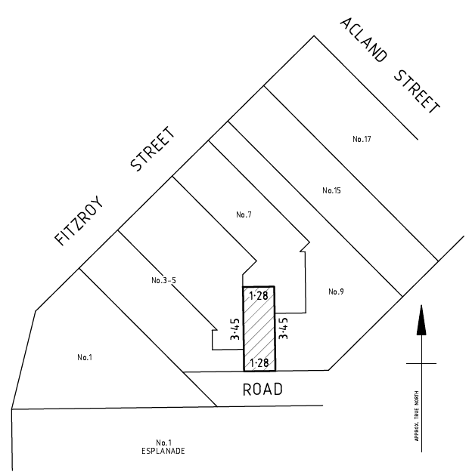

Further information regarding the proposal can be obtained from Port Phillip City Council (Kate Psomotragos via phone: 03 8563 7989).

Any person may make a submission on the proposal. Any person wishing to make a submission must do so in writing by Wednesday 20 December 2023.

Submissions should be submitted via Council’s website or addressed to Kate Psomotragos and posted to Port Phillip City Council, Private Bag 3, St Kilda, Victoria 3182. Submissions can also be hand delivered to 99A Carlisle Street, St Kilda 3182.

All submissions will be considered in accordance with section 223 of the 1989 Act. No further community consultation process will be undertaken.

Any person making a submission is entitled to request in the submission that the person wishes to appear in person, or to be represented by a person specified in the submission, at a meeting to be heard in support of that submission.

Any person requesting to appear in person or to be represented by a person specified in his or her submission will be notified of the day, time and place of the meeting of the Council or of a committee determined by the Council to hear submissions.

Following consideration of submissions, Council may resolve not to discontinue the road or to discontinue the road and either sell the land from that road or retain the land.

|  |
| --- |
| Chris Carroll  Chief Executive Officer |