# 10 February 2025

Dear Resident / Trader,

**FORMULA 1 AUSTRALIAN GRAND PRIX 2025- Local Parking Area**

The FORMULA 1 AUSTRALIAN GRAND PRIX 2025 will return to Albert Park from **Thursday 13 March to Sunday 16 March 2025**. The City of Port Phillip and the Australian Grand Prix Corporation (AGPC) will work together to minimise disruption to the community before, during, and after the event.

This letter outlines temporary parking changes to be put in place over the four-day event period. These changes are designed to discourage Grand Prix visitors from parking in local streets, while still providing ease of access to residents, traders and visitors to local schools, businesses, and community centres.

# **2025 Parking Management Approach**

In 2025, the City of Port Phillip, together with AGPC will continue to implement a restricted parking zone for the local area. This will include the implementation of temporary parking restrictions in Middle Park and Albert Park. The restricted parking zone for 2025 is shown in Image 1 and remains unchanged from 2024.

We will monitor the success of this zone carefully throughout the event and make further improvements should they be required.

Council’s Parking Enforcement Officers will patrol the area for illegally parked vehicles, with additional resources rostered to patrol areas potentially affected by patrons visiting the Grand Prix. They will also prioritise assisting with any reports of cars blocking driveways or restricting access for any resident.

All vehicles must comply with signposted parking zones or display a valid parking permit to be exempt from time limit restrictions. Illegally parked vehicles will be subject to fines and towaways for obstructing access.

The following temporary parking restrictions will apply from **Thursday 13 March to Sunday 16 March:**

* Existing 4P and unrestricted zones will be adjusted to 90-minute zones.
* Existing 2P, 1P, or permit zones which only operate Monday to Friday (or Monday to Saturday) will be adjusted to also include Saturday and Sunday.
* Existing loading zones, clearways or disability parking bays will not be modified.

# **Local Resident Exemptions**

Enclosed with this letter are two Temporary Parking Permits. To be exempt from these time limit restrictions during the four-day event, one of the following City of Port Phillip issued parking permits must be displayed in your vehicle:

* Resident Parking Permit
* Visitor Parking Permit
* Combined Parking Permit
* Temporary Parking Permit (enclosed).

Please note that residents are not required to display temporary permits prior to the Grand Prix event, however, you still must abide by any existing parking restrictions.

Additional permits may be requested by contacting City of Port Phillip ASSIST on 9209 6777. AGPC are unable to distribute Temporary Parking Permits.

Please note that these local resident exemptions do not permit parking in loading zones or disability parking bays.

# **Signage**

Temporary parking restriction signage installation will commence from Wednesday 27 February 2025. The temporary restrictions will be enforced only from Thursday, 13 March, to Sunday, 16 March (inclusive). Original parking restrictions will be reinstated in the days following the event's conclusion.

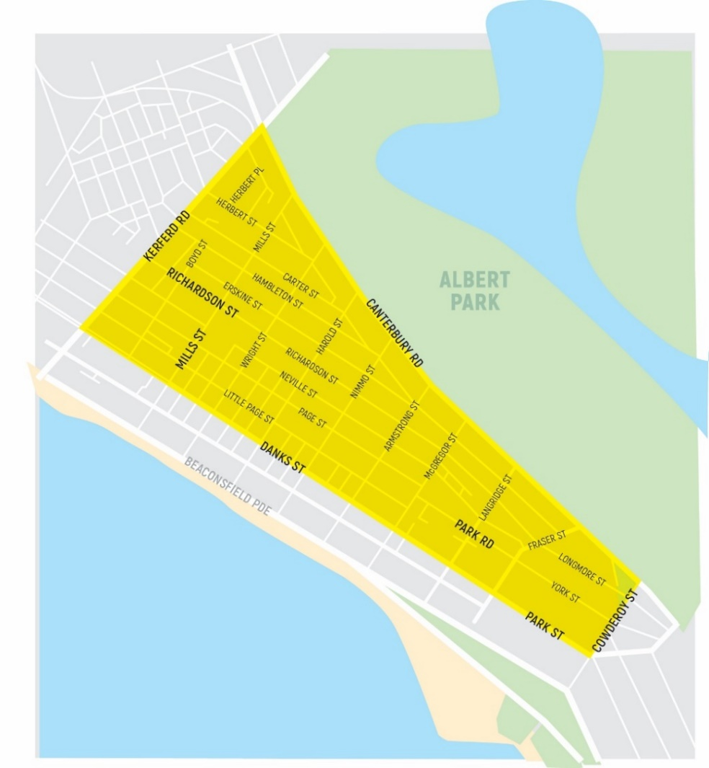

**Image 1** Restricted parking area 13 – 16 March 2025

# **E-scooter use during the Grand Prix**

In response to community concerns, dedicated spaces for shared mobility parking will be provided to minimise safety and amenity issues experienced.

E-scooter operators will be on-site throughout the event undertaking proactive patrols with the strong expectation that they will respond promptly to any issues.

For any issues with scooter parking locally, please contact Lime and Neuron directly on:

* Lime by calling 1800 861 305 or emailing melbourne@li.me
* Neuron by calling 03 4517 6860 or emailing melbournesupport@neuron.sg



For more information

portphillip.vic.gov.au/grand-prix-parking ASSIST 03 9209 6777

**For Grand Prix parking and traffic information**

An overview of event information relevant to the local community can also be found enclosed with this letter. For more detailed information relating to the event, please visit grandprix.com.au/community/local-information

Yours sincerely,

Chris Carroll

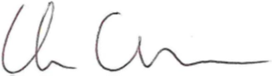

Chief Executive Officer

City of Port Phillip

Tom Mottram



Chief Events Officer

Australian Grand Prix Corporation