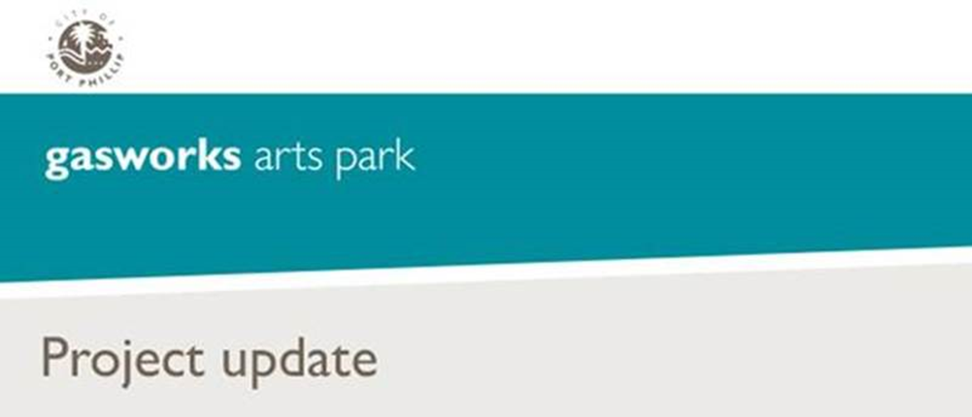

December 2017 Update
Gasworks Arts Park Contamination Management Plan
What’s been happening?
During 2017, environmental consultants CH2M conducted soil, soil vapour and groundwater sampling across the park. Sample analysis has begun and the results will assist with developing the draft Contamination Management Action Plan (CMAP).
Data gaps identified during the initial sampling and monitoring phase have revealed the need for further soil vapour sampling and groundwater monitoring to address the Environmental Audit requirements.
Next steps
In late 2017 through to early 2018, further soil, soil vapour and ground water sampling will be conducted. Once these samples have been completed and analysed, CH2M will incorporate the results into the draft CMAP report which will submitted to the EPA accredited auditor to guide next steps.
CH2M will be onsite in December 2017 to undertake the further soil vapour sampling within selected buildings at Gasworks Arts Park. Minimal disruption is expected for park users during this period.
Council will make the draft CMAP available to the community once it has been completed. This is likely to be in 2018.
We will continue to keep the community informed as these works progress.
More information
If you have any questions or require further information:
- Visit the Gasworks Arts Park soil containment webpage
- Contact ASSIST on (03) 9209 6777
- Email the Project Manager

