**Rupert Bunny Foundation Visual Arts Fellowship**

The Rupert Bunny Foundation Visual Arts Fellowship (RBFVAF) is an acquisitive award of $30,000 presented to a recipient once every two years. Established in 2005, it aims to support contemporary visual artists with an identifiable commitment to arts excellence.

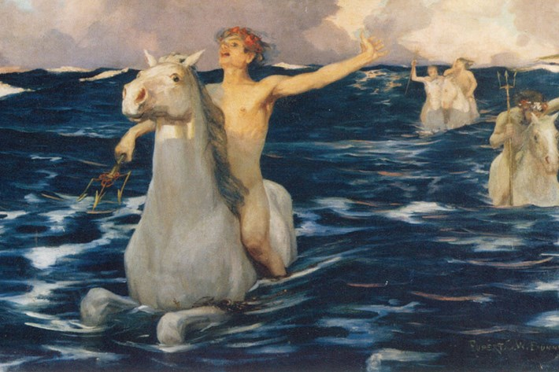

Rupert Bunny, The Forerunners (detail) c 1894. Oil on linen, 129 cm x 229 cm

The Rupert Bunny Foundation Visual Arts Fellowship (RBFVAF) was established in 2005. The RBFVAF aims to support a contemporary visual artist with an identifiable commitment to visual arts excellence. The successful Fellow will have a desire to extend their arts practice to a new level, expand their imagination and make a contribution to the City of Port Phillip through either or all of the following:

* **Conduct research and development**that increases or expands a professional artist's skills or thinking, particularly towards producing a major artwork or work
* **Produce an artwork or artworks**that make a significant contribution to the field of contemporary visual art and exhibit within the City of Port Phillip
* **Travel or take up a residency** that enables the outcomes of any of the other objectives of the Fellowship
* **Donate artwork** to the Port Phillip City Collection.

The Rupert Bunny Foundation Visual Arts Fellowship is overseen by a [Reference Committee](https://www.portphillip.vic.gov.au/about-the-council/governance-performance-and-advocacy/special-and-advisory-committees) who provide strategic advice, expertise and recommendations to Council on the dispersal of Rupert Bunny Funds according to the VCF-RBF Deed of Trust.

The City of Port Phillip is recognised for its rich cultural diversity and acknowledges that artists play a vital role in sustaining a creative city. The City believes in supporting the development of exceptional artistic thinking and talent.

**2024 Rupert Bunny Foundation Visual Arts Fellowship: applications now open**

Rupert Bunny Foundation Visual Arts Fellowship (RBFVAF). The City of Port Phillip invites applications for an acquisitive award of $30,000 in support of professional development and excellence in contemporary visual art – 1 recipient

**How to apply for the 2024 RBFVAF**

The City of Port Phillip uses the SmartyGrants online grant application system.

Read the 2024 RBFVAF Guidelines [insert link]. It includes information on Key Selection Criteria, eligible funding items and tips for applying.

[2024 Rupert Bunny Foundation Visual Arts Fellowship Application Form](https://portphillip.smartygrants.com.au/RBFVisualArtsFellowship2017) [insert correct link]

**Key Dates**

* Applications open: 9 am Tuesday 9 April 2024
* Applications close: 5 pm Monday 20 May 2024

To find out how to register, apply for a password and for tips on navigating the form, check the [Help Guide for Applicants](http://cms/cms/ioLoadImage.asp?FolderGuid=765A45ABF3B1424CBC056EFF821FAF76/Help_Guide_for_Applicants_.pdf) [insert link]. Please read the key instructions in the Help Guide and the application form carefully.

If you have any queries about navigating the online application or do not receive a submission confirmation email or to discuss a project idea please call 03 8563 7862 or email [rbf@portphillip.vic.gov.au](mailto:rbf@portphillip.vic.gov.au) [insert link]

**Engaging with an Auspice organisation**

The City of Port Phillip will require successful applicants who are individual artists to engage an auspice organisation to assist to manage the grant.

Find out more on [how to work with an auspice organisation (DOCX 42KB)](https://www.portphillip.vic.gov.au/media/sdrfnm4y/amended_how-to-work-with-an-auspice_july-2021.docx) [insert link]

Applicants are required to submit a letter of confirmation from their auspice organisation with their application as support material. Applicants should contact an auspice organisation a **minimum of 10 working days** before the application due date with a brief project description and draft budget if possible.

For the City of Port Phillip creative grants programs, the key auspice organisations supporting artists are:

* [Auspicious Arts Projects](https://www.auspicious.com.au/)
* [Arts Access Victoria](https://www.artsaccess.com.au/) for artists with access and disability needs.
* [Multicultural Arts Victoria](https://www.mav.org.au/) for multicultural projects or artists from culturally diverse backgrounds

An auspice organisation may charge a small administration fee. Applicants should include in their budgets an auspice administration fee which may range between 5 per cent and 20 per cent of the grant total depending on the organisation and level of assistance.

**Application Supplementary Material**

Please read the instructions about application supplementary material in the Guidelines and Application Form carefully.