Community Funding Policy

## Contents

1. Purpose 3

2. Policy context 3

3. Guiding principles 5

4. Definitions 6

5. Scope 8

6. Policy statement 8

7. Funding management framework 9

Community Investment Funding Model 10

8. Conflict of interest 11

9. Relevant legislation, policies and other documents 11

10. Review and feedback 11

11. Appendix A 12

12. Appendix B 13

13. Appendix C 14

14. Appendix D 15

## Purpose

* 1. The City of Port Phillip is committed to funding community activities and programs that align with the Council Plan 2017-27 to support and promote a liveable, inviting and real community. A City where people are welcomed and belong, creativity is encouraged and history is celebrated.
  2. Councils investment in sustainable community outcomes is a key strategic priority with significant funding activity occurring across the City. In delivering on those outcomes, Council funding can be a strategic and potent drivers, particularly when partnering with the community.
  3. This policy provides the guiding principles and accompanying framework for the delivery of grants subsidies, donations and funding agreements in the City of Port Phillip to community organisations and individuals.
  4. The Community Funding Policy is supported by Council’s operational frameworks and processes which include the:
     1. Funding Management Framework
     2. Program Logic
     3. Funding Lifecycle, and
     4. other grants related procedural documents (see Appendix B).

## Policy context

Objectives of a Council

* 1. The Local Government Act (1989) identifies the primary objective of a Council as one that endeavours to achieve the best outcomes for the local community having regard to the long term and cumulative effects of decisions.
  2. In seeking to achieve this primary objective, Council has a role in:

1. advocating the interests of the local community to other communities and governments
2. acting as a responsible partner in government by taking into account the needs of other communities
3. fostering community cohesion and encouraging active participation in civic life, and;
4. ensuring transparency and accountability in Council decision-making.
   1. Community Grants programs and strategic funding agreements are one of the key ways in which local governments can enter into partnership with community organisations and groups to meet community needs, support local networks, encourage participation in community life, facilitate innovation and responsiveness in community service provision, and promote access, inclusion and acceptance of diversity.[1] When councils support and resource community groups in seeking funds and achieving outcomes, the relationship between local governments and local communities can be strengthened.[2]

Alignment to the Council Plan

* 1. The Council Plan sets out six strategic directions to deliver the vision for the City of Port Phillip. The Council Plan is structured around these directions and the desired outcomes for the health and wellbeing of the community and places that are to be achieved by 2027.
  2. The Community Funding Policy operates in alignment with the Council’s six strategic directions:

| **Strategic Directions 2017-27** | **How the Community Funding Policy aligns** |
| --- | --- |
| 1. We embrace difference, and people belong | * Providing Guiding Principles that value and encourage lifelong learning, enhance social connection, support cultural diversity and provide opportunities that support the health and well-being of our growing community * Working with community organisations that demonstrate their ability to deliver on this key strategic objective and support inclusivity in the City of Port Phillip |
| 2. We are connected and it’s easy to move around | * Working with the community and partners on programs that improve social connections and integrated transport solutions |
| 3. We have smart solutions for a sustainable future | * Supporting programs that improve or deliver environmentally sustainable community assets and outcomes |
| 4. We are growing and keeping our character | * Facilitating supportive structures to enable advocacy of positive planning and sustainable development outcomes, alongside provision of programs and activities that respond to growth and the changing needs of our community |
| 5. We thrive by harnessing creativity | * Providing frameworks and supporting the community organisations that facilitates a network of active and informed communities that support and encourage opportunities for creative endeavours |
| 6. Our commitment to you | * Ensuring transparency and placing a high value on open and transparent communication and collaborative engagement with the community |

## Guiding principles

The following guiding principles underpin best practice in funding and grants management and administration at the City of Port Phillip and apply throughout the Funding Lifecycle (see Appendix A). These principles support the Council’s commitment to improve and protect the health and wellbeing of the community

* 1. **Social Justice** – Our funding approach encompasses the key values of social justice that aim to decrease inequity and establish environments that are inclusive, connected, supportive of all people and improve areas of social isolation.
  2. **Sustainability** – We support and encourage:
* environmentally sustainable practices in the way we manage our funding
* the application of sustainable approaches to community funded projects and services
* building business models that support and assist the long-term future of community organisations
* consideration of localised responses to community funded projects and services
  1. **Robust planning and design** – Our funding administration is efficient, effective and ethical, which includes an evidence based approach and the establishment of effective risk management processes.
  2. **Proportionality** - Our program design and administrative processes are commensurate to the scale, complexity and risks associated with the funding.
  3. **Governance and Accountability** – We have a robust governance framework in place that:
* defines Council and community roles, responsibilities and accountabilities
* establishes the policies, procedures and guidelines necessary for funding recipient selection
* supports public accountability for decision making, funding administration and performance monitoring.
  1. **Probity and transparency** – Our program administration reflects public sector values, ensuring that our funding decisions are impartial, transparent and well documented, and that appropriate measurement, reporting and fraud measures are in place.
  2. **Maximise outcomes** – Our funded programs are aligned with our strategic directions to deliver maximum value for money and the best possible outcomes for the community.
  3. **Positive working relationships** – We place a high value on cultivating relationships that focus on trust, transparency and partnerships to achieve optimum outcomes.
  4. **Flexibility and responsiveness** – Our programs respond to changing economic indicators, business, environment and community needs.

## Definitions

Key terms and definitions used throughout this document are shown in the table below and are consistently applied across the City of Port Phillip and the Funding Management Framework.

| **Term** | **Definition** |
| --- | --- |
| Assessment Criteria | The specified principles or standards against which applications are judged and used to assess the merits of proposals. |
| Assessment Process | The steps that must be followed by individuals and organisations to be considered for a grant. It includes the forms, written documentation and the eligibility and assessment criteria to be satisfied. |
| Community Organisation | Not for profit organisations and groups that encompass a wide range of activities, programs and services aimed at improving people’s quality of life. The community sector varies significantly in size and can range from small volunteer run and locally based groups to large national organisations with many staff (also known as community sector, not for profit organisations, or community service providers). |
| Conflict of Interest | A conflict of interest arises where a person makes a decision or exercises power in a way that may be, or may be perceived to be, influenced by either material to personal interests (financial or non-financial) or material personal associations. |
| Eligibility Criteria | The mandatory principles or standards that must be met for an application for funding to be considered. Eligibility criteria may apply in addition to assessment criteria. |
| Funding | A sum of money or form of subsidy that Council provides to an individual or organisation under a formalised agreement. |
| Funding Agreement | A formal, legally-binding contract established with a funding recipient, which is then used as the primary legal instrument to monitor implementation of the funded activity through to its completion.  The funding agreement states the purpose of the funding, the financial amount, and the conditions of the funding including key deliverables. It also defines the rights and responsibilities of the parties. Once signed, parties are under a legal obligation to comply with the stated terms and conditions. |
| Funding - Donation | An offering of cash or in-kind contribution given without any anticipated commercial return. |
| Funding – Strategic Partnership | A partnership that has been entered into between Council and a community organisation so they can work collaboratively to achieve common outcomes. Strategic partnerships include the provision of funding to deliver on an idea or initiative that will improve the community’s health and wellbeing and is aligned with the Council’s strategic priorities. |
| Funding - Subsidy | Financial aid or benefit supplied to a community group in the form of fee reduction for reasons of: public welfare; reduction of financial burden; being in the public interest and/or to maintain prices at a certain level. |
| Grant | A sum of money given to a recipient (i.e. organisations or individuals) for a specified purpose directed at achieving goals and objectives consistent with government policy. Grant recipients are selected on merit against a set of criteria.  Grants typically, but not always, have conditions attached, such as reporting obligations and key performance indicators. Grants may be dispersed on a one-off or longer term basis, but aren’t provided as ongoing, permanent funding[3]. |
| Grants Administration | The end-to-end grant management process which includes: planning and design; assessment and decision-making; grant establishment; agreement and relationship management; monitoring; acquittal and review and evaluation. |
| Grant - Contested | Grant programs that have publicly available guidelines and application processes. Funding is awarded on a competitive basis where a grant application is selected on merit following assessment against a set of criteria. |
| Grant - Negotiated | Non-competitive grants awarded to target recipients through discrete programs that are not advertised publicly. Funding may be awarded to one or multiple recipients. |
| Grant - Targeted | Grants are awarded to a defined group of recipients. It can involve a two-stage process where a market needs to be tested or properly defined. |
| Grant - Timeframe | Grant payments can be made on a one-off basis, for a short time period or over multiple years under a funding agreement. |
| Proportionality | In the context of funding, proportionality involves ensuring a reasonable balance between the complexity of a funded activity, including the ongoing requirements for funded recipients, and managing the overall risks for beneficiaries and Council (or the Government). |
| Probity | Honesty, ethical behaviour and ‘good process’. In the context of a funded program, good process will involve: clear decision-making procedures and criteria, all applicants being treated consistently and equitably, and decisions being made in a transparent manner which allows them to be understood and justified. |
| Program Design | The process undertaken to develop a program prior to program implementation.  Program design will often include development of an implementation plan, consideration of resource or training requirements, and agreement on a governance structure. Program design should also include the development of an evaluation plan. |
| Program Logic | A method to depict the logic or pathways through which the programs processes (i.e. inputs, activities and outputs) are intended to achieve the desired outcomes. The Program Logic can assist with in understanding how the program is intended to work, what it is trying to achieve and why. |
| Transparency | Transparency provides assurance that funding administration processes undertaken are appropriate and that policy and legislative obligations are being met. This involves open scrutiny of the reasons for all decisions and provision of information to government, the Parliament and the community. |

## Scope

* 1. This policy applies to all:

1. Council departments and to all phases of the funding lifecycle, to direct the provision of consistent and transparent funding administration and management.
2. Councillors, council officers and other persons, including temporary and contract staff.
   1. The implementation of the Community Funding Policy, is supported by a Funding Management Framework and funding lifecycle, which provides structural and administrative roadmaps for funding activities across Council (See 7. Funding Management Framework).

## Policy statement

* 1. The City of Port Phillip recognises that its community grants programs, subsidy schemes, donations and funding agreements provide a strategic opportunity to work in partnership with community groups, organisations and individuals to strengthen community capacity and promote a liveable, inviting and real City of Port Phillip.
  2. Council will ensure that funding processes reflect strategic objectives and are delivered in a fair and transparent manner to foster civic engagement, strengthen a sense of community and place, promote health and wellbeing and reduce isolation and social exclusion within the City of Port Phillip community.
  3. This policy:
* draws upon Council's existing strengths and builds on the skills, ideas and ingenuity of the local community
* values the capabilities and willingness of groups, organisations and individuals to contribute to the overall well-being of the community
* acknowledges the mutual benefits of the Council and community working together
* enables and promotes community leadership in delivering outcomes.
  1. Council’s Funding Management Framework ensures that Council will only provide funding, which demonstrates links to the Council Plan’s strategic objectives, clear program budgets, eligibility criteria, application and assessment processes. Funding recipients can have confidence that what they have been awarded is based on the quality of their proposal to achieve the designed outcomes.
  2. Council will review funding categories annually to ensure:
     1. alignment with Council Plan’s 2017-27 strategic objectives and community needs
     2. the effectiveness of each individual program in responding to the priorities. This process will assist in identifying new and emerging needs and inform adjustments of priorities and allocations of funding and,
     3. the effectiveness and efficiency of operational and administrative processes of the funding which includes, but is not limited to eligibility and assessment, decision making, monitoring and reporting, review and evaluation.
  3. The results of the review will be used by Council to inform and improve updates to, and implementation of the Community Funding Policy.

## Funding management framework

* 1. The diagram below provides an illustration of a robust funding management framework. This provides a foundation for all funding and grant management activity and ensures alignment with Council strategies and plans. Embedding a robust funding management framework and funding allocation model helps to support Council’s community investment decisions and the achievement of outcomes.

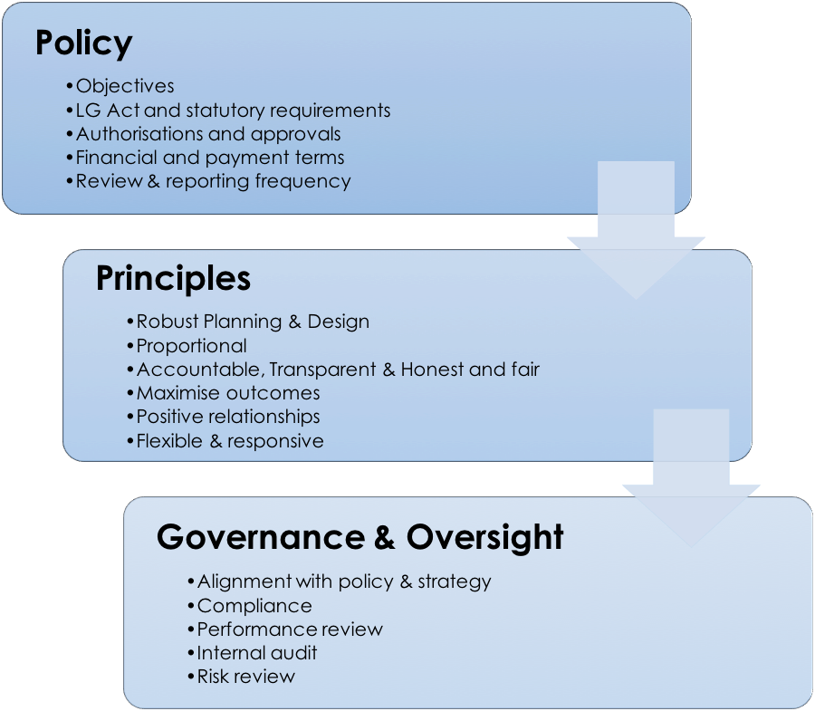

*Figure 1 – Funding Management* *Framework*

* 1. The central objective of this Policy framework is to improve transparency and accountability of funding administration through a consistently applied funding lifecycle (see Appendix A).
  2. The framework enhances the capacity to design and implement administrative arrangements to ensure that policy objectives are met, ensuring efficient and effective compliance with all applicable obligations. The framework guides the implementation of the Community Funding Policy and follows key steps in the funding lifecycle to ensure quality processes and continuous improvement.
  3. The framework also defines the roles and responsibilities of the various participants involved in the administration and delivery of funding and grant-making activities (see Appendix C).

### Community Investment Funding Model

* 1. As a key part of the Funding Management Framework, the Community Investment Funding Model provides one central entry point for the community to access grant funding aligned with improving outcomes for the City of Port Phillip community.
  2. It aligns the councils operational principles and Council Plan into streams of funding that enable consistent application of grant making, ability to leverage activity and an oversight of funding that is transparent and targeted for achieving outcomes.

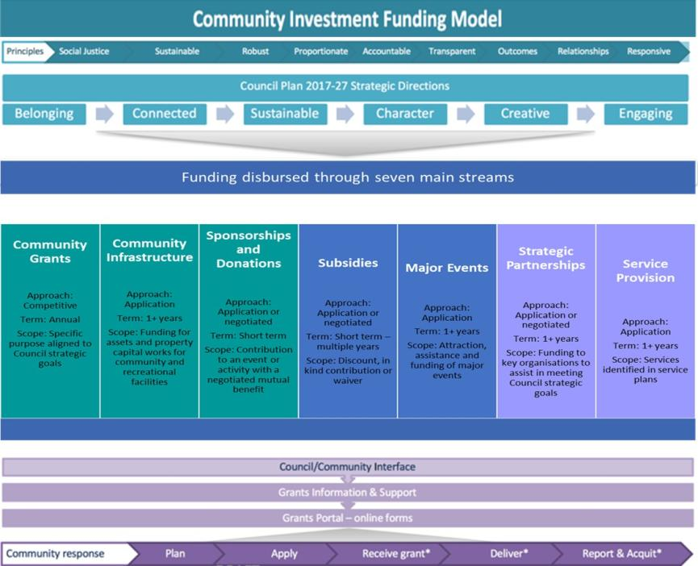

## Conflict of interest

* 1. A conflict of interest occurs when there is a conflict between a person's private interests and their public obligations.
  2. All Councillors, council officers and community members involved in funding assessment processes are required to declare their interests prior to assessing any applications or reviewing project evaluations and reports. This process ensures that any **potential**, **actual** or **perceived conflict of interest** is promptly identified and managed appropriately.
  3. In the event of a conflict of interest, the relevant person must decline to participate in any discussion about the application or report and have this declaration noted as per Council’s conflict of interest process.

## Relevant legislation, policies and other documents

### Legislation

* Local Government Act 1989
* City of Port Phillip - Local Law No. 1 (Community Amenity) 2013

### Policies and other documents

* City of Port Phillip Council Plan 2017-27
* City of Port Phillip Health and Wellbeing Implementation Strategy 2017-21
* City of Port Phillip Risk Management Policy and Risk Management Framework
* City of Port Phillip Procurement Policy
* City Of Port Phillip Social Justice Charter
* City of Port Phillip Creative and Prosperous City Strategy (draft)
* City of Port Phillip Organsational Strategy

## Review and feedback

* 1. The Community Funding Policy will be reviewed, updated and improved every 12 months.
  2. Feedback about this document may be made by email to [grants@portphillip.vic.gov.au](mailto:grants@portphillip.vic.gov.au)

## Appendix A

Steps in the funding lifecycle

Funding Lifecycle including planning,design,delivery,dynamics and improve.

## Appendix B

Key elements of funding structures

Key elements funding pyramid including legislation, council plan, funding policy, funding management framework and funding life cycle- operations.

## Appendix C

Summary of Governance roles involved in funding at the City of Port Phillip:

1. **Council**

Approve the Community Funding Policy and associated updates on an annual basis to:

* ensure alignment with Council’s strategic objectives and community needs
* support planning and decision making and achievement of community outcomes.

1. **Executive Leadership Team**

Support Council decision making by:

* endorsing the Community Funding Policy for approval by Council
* ensure that funding processes reflect strategic objectives and are delivered in a fair and transparent manner
* champion best practice grants and funding management across Council.

1. **Community**

Demonstrate community leadership by:

* engaging with their communities to develop proposals that encourage inclusion and creativity, celebrate the history of Port Phillip, protect its character and work with Council to plan for the future of a dynamic and evolving City
* actively engage with Council and read Council’s information packs, policies and plans, to ensure that their proposals align with the strategic objectives of the City of Port Phillip Council Plan 2017-27 and contain clear objectives, measurable outcomes and evidence of genuine partnership and collaboration.

1. **Council Funding and Grants Working Group (comprises funding and grant managers)**

Demonstrate Council leadership by:

* acting as a specialist advisory group to review and make recommendations on issues that may arise in relation to the Community Funding Policy and related processes and procedures
* actively modelling best practice funding and grants knowledge and processes
* undertaking a review of the Community Funding Policy and associated processes every 12 months.

## Appendix D

High Level Funding Program Logic

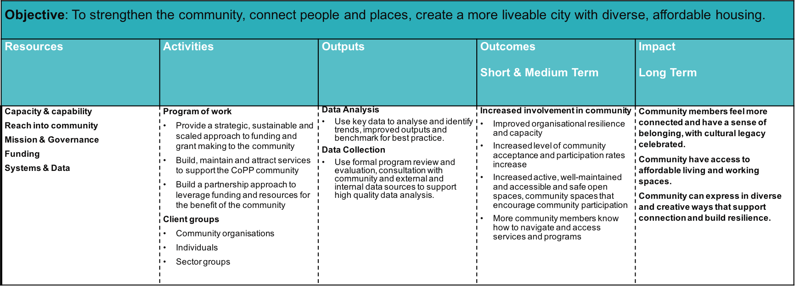

1. The Victorian Local Government Association reference Best Practice in Local Government Community Grants Programs (2002)
2. The Victorian Local Government Association reference Best Practice in Local Government Community Grants Programs (2002)
3. Australian Taxation Office, Business reports and returns, Government entities, 2017