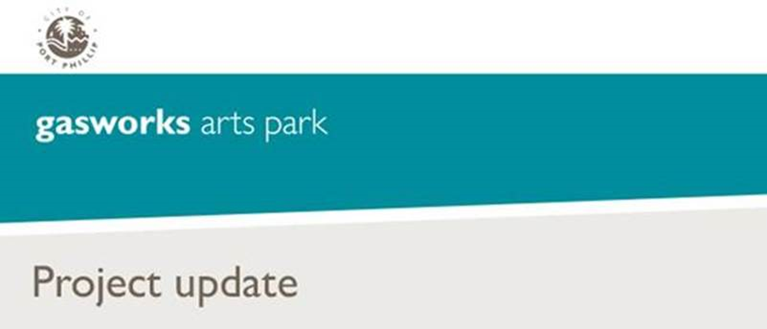

July 2018 Update
Gasworks Arts Park Contamination Management Plan
What’s been happening?
Extensive testing and analysis has been undertaken by the State Government to create a comprehensive understanding of the soil, soil vapour and groundwater across the park.
Preliminary findings have confirmed that contamination is widely spread in the soil profile. However, the extensive testing and analysis to create a comprehensive knowledge of contamination has presented an opportunity to revisit the human health risk assessment with the EPA auditor, by:
- Reducing the assessment depth for soil contamination across the site with international benchmarking and a more comprehensive data set (e.g. contaminates within the top 300mm layer)
- Defining and controlling usage on the site (e.g. vehicle traffic)
- Developing a draft Park Plan to demonstrate compliance to a draft Contamination Management Action Plan (CMAP)
Next steps
Further work to determine the extent and management options for groundwater contamination is still needed. A Remediation Action Plan (RAP) is required to address groundwater contamination, and the EPA accredited auditor is overseeing these works.
It’s expected that any works required to manage groundwater contamination will be restricted to targeted areas of the park. The groundwater RAP is expected to be completed at the same time as the draft CMAP.
The draft CMAP and groundwater RAP address contamination in different ways. The draft CMAP considers the environmental and human health risks associated with exposure to contaminated soil, whilst the groundwater RAP predominately addresses the potential environmental risks as a result of the contaminated groundwater, which is located far below the surface.
Subject to approval by the EPA accredited auditor, it’s anticipated that the draft CMAP and groundwater RAP will be completed at the same time in mid-2019.
The preliminary findings of the draft CMAP are consistent with the interim management plan for Gasworks Arts Park. The Environment Protection Authority (EPA) Victoria has deemed the site safe for ongoing use as a public park and will remain open to the community during these works.
Gasworks Park Plan
To ensure any proposed and future works at Gasworks Arts Park comply with the draft CMAP, Council are now working with the Victorian Government to develop a draft Park Plan. The Park Plan will be developed over the next 9 to12 months while works to better understand groundwater contamination continue.
The draft Park Plan will consider and incorporate the significant community feedback received as a result of previous community consultation on the 2014 Gasworks Arts Park draft park plan. The draft Park Plan will also demonstrate Council’s commitment as part of the December 2014 Resolution to maintain as many trees as possible and retain the park as an off-leash park in a native bush setting.
Council will seek feedback on the draft CMAP, RAP and draft Park Plan when concluded and approved by the EPA.
More information
If you have any questions or require further information:
- Visit the Gasworks Arts Park soil containment webpage
- Contact ASSIST on (03) 9209 6777
- Email the Project Manager

