# Cultural Development Fund - Projects

**On this page:**

* 2020/21 Cultural Development Fund (CDF) - Projects applications
* What is the CDF?
* Guidelines and criteria
* How to apply
* Previously funded projects
* CDF Reference Committee
* Access and support information
* Other funding opportunities and resources

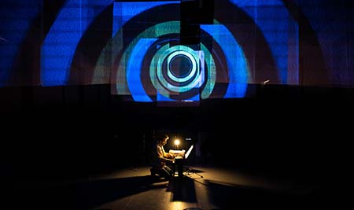

Image caption: Glitch, Jacob Abela, Rubiks Collective 2019. Photo: Cameron Jameison

## 2020/21 Cultural Development Fund (CDF) - Projects applications

Applications to 2020/21 annual CDF - Projects grants have now closed.

**Upcoming opportunities**

To hear about upcoming funding rounds or other arts opportunities and news in Port Phillip subscribe to our monthly e-news.

For further information about the Cultural Development Fund, contact Sharyn Dawson on 03 9209 6165 or [cdf@portphillip.vic.gov.au](mailto:cdf@portphillip.vic.gov.au)

## What is the CDF?

The CDF is an annual arts and heritage grants round for artists and related organisations in Port Phillip. Applicants to the Fund may apply for up to $12,000 per project.

The CDF seeks to:

* support artists and organisations to develop and realise creative projects in the City of Port Phillip
* support community managed projects
* generate arts and cultural activity
* build cultural identity
* support and celebrate community diversity
* support heritage initiatives.

**Who can apply?**

* Individual applicants who live or work in the City of Port Phillip and have engaged an auspice organisation for the purpose of applying for and managing a Cultural Development Fund grant. (See eligibility notes in the Guidelines and criteria document below)
* Artists of Boon Wurrung descent are also eligible to apply.
* Unincorporated groups who have engaged an auspice organisation and are based in the City of Port Phillip
* Incorporated arts and related community organisations based in the City of Port Phillip.

See eligibility notes in the Guidelines and criteria document below .For more information, contact the Cultural Development Fund Officer on 03 9209 6165

## Guidelines and criteria

2020/21Cultural Development Fund Guidelines and Criteria (DOCX 661 KB)

2020/21 Cultural Development Fund Guidelines and Criteria (PDF 708 KB)

Consider discussing your project idea with the Cultural Development Fund officer before submitting an application. Applicants proposing projects in public space should discuss the proposal with the Fund officer well in advance of the submission date.

**For further information contact**

Sharyn Dawson, Cultural Development Fund Officer on 03 9209 6165 or email cdf@portphillip.vic.gov.au

## How to apply

The City of Port Phillip uses the Smartygrants online application system.

Links to the application forms can be found here when a round is open.

## Previously funded projects

In 2019 Council received 39 applications to the Fund. A total of $183,555 has been awarded to 19 projects.

2019/20 Successful Cultural Development Fund recipients (DOCX 61KB)

2019/20 Successful Cultural Development Fund recipients (PDF 510 KB)

2018/19 Successful Cultural Development Fund Recipients (DOCX 59 KB)

2018/19 Successful Cultural Development Fund Recipients (PDF 321 KB)

## Cultural Development Fund (CDF) Reference Committee

Community members with arts and cultural expertise hold four voluntary positions with a Councillor representative on the Cultural Development Fund Reference Committee. This Committee meets annually to assess applications to the CDF - Projects round.

## Access and support information

For general Council information about the National Relay Service, language translation and Auslan translation services see the Accessibility page.

For Metro Access support contact 03 9209 6829.

## Other funding opportunities and resources

Other City of Port Phillip grants via Funds, Grants and Subsidies

Funding Opportunities for Artists and Organisations (DOCX 13 KB)

Art and Soul - Creative and Prosperous City Strategy (PDF 31 KB)

Council Plan 2017-27

**More information**

Contact Us or use Online Services to ask us a question, request information or give us feedback online.