**Graffiti   
Management Plan**

2019-24

## Contents

Message from the Mayor 3

Why we need this plan 4

Outcomes 4

Terminology and principles 5

Graffiti 5

Street art 6

Graffiti hotspots 6

Crime Prevention Through Environmental Design (CPTED) 6

Graffiti mitigation 6

Precinct management 6

Community correctional programs 7

Graffiti legislation 7

Enforcing offences under the Act 8

Developing the Plan 9

How we evidenced priorities 9

Examining graffiti statistics 9

Listening to our community 11

Consultation on best practice principles 12

Our partners 14

How we’ll get there 15

Outcome 1: Trusted service levels 15

Outcome 2: Ease of access for services offered 16

Outcome 3: Improvements in liveability 17

Outcome 4: Collaboration with partners and our community 19

Outcome 5: Evaluation and measuring of success 22

Acknowledgements 23

Related documents and attachments 23

Graffiti management - Five year Implementation Action Plan 2019-24 24

Outcome 1: Trusted service levels 25

Outcome 2: Ease of access for services offered 26

Outcome 3: Improvements in Liveability 27

Outcome 4: Collaboration with partners and our community 29

Outcome 5: Evaluation and measuring of success 30

## Message from the Mayor

**The Councillors and I are pleased to release our Graffiti Management Plan 2019-24.**

The Port Phillip community is growing fast and our expanding population has consistently communicated to us the importance of our City feeling safe and welcoming to all. We are proud of our City’s reputation as being vibrant and creative and continue to champion the arts widely. While freedom of creative expression is hugely important to us, illegitimate graffiti is often cited as a factor that contributes to negative perceptions of safety on our streets.

Data reflects that the volume of graffiti in Port Phillip remains fairly consistent. However, we have seen significant increases in the rate at which graffiti is being reported to us. Consequently, we are working even harder to address graffiti and illegal tagging in our City, managing the necessary removal of graffiti in conjunction with the promotion and support of graffiti mitigation measures that more broadly benefit our community.

The Graffiti Management Plan 2019-24 (the Plan) sets out targets and service levels for graffiti management in our City, and details how these will be achieved. It is an action statement for our community and partners to collaborate with us in managing graffiti better over the next five years, while we investigate opportunities to achieve even better outcomes in the future.

As our residential, business and visitor populations continue to grow, we need to ensure we remain a City with clean and inviting streets, parks and foreshore areas for everyone to enjoy.

**Cr Dick Gross**

Mayor

City of Port Phillip

## Why we need this plan

**The Graffiti Management Plan 2019-2024 (the Plan)** provides a clear framework and guidelines for the management of graffiti within the City of Port Phillip.

The Plan outlines Council’s approach to dealing with illegal graffiti, as well as outlining opportunities to mitigate against future graffiti and how this aligns with Council’s wider strategies.

### DecorativeOutcomes

The City of Port Phillip’s Graffiti Management Plan aims to demonstrate:

* trusted service levels on graffiti removal and other associated graffiti mitigation services
* ease of access for services offered to our community, including the provision of an efficient and trusted process to report and action the removal of graffiti in our City
* improvements in liveability for our community through the provision of equitable and accessible resources
* information and advice as to how Council will prioritise collaboration with partners and our community to keep our streets clean and welcoming to all
* a key set of objectives as targets to be achieved within the period covered by the Plan to ensure evaluation and measuring of success.

## Terminology and principles

The following section lists **terms and principles** that are commonly used in the context of graffiti and graffiti management.

### Graffiti

Graffiti is the writing or application of any unauthorised inscription, figure or mark on a surface. Such a mark may be painted, sprayed, etched, drawn, pasted, scratched or otherwise affixed.

| **Types of graffiti** | **Definition** |
| --- | --- |
| Bomb | The act of painting many surfaces in an area resulting in dense graffiti completed over a short period of time. |
| Buff | The act of removing or painting over graffiti. |
| Capping | To tag or paint over the top of another graffiti artist’s work, obliterating the original piece. |
| Etching | The use of acid solutions to tag on glazed surfaces. |
| Ghost | Marks left after the removal of graffiti, often due to the porous or aged nature of the surface beneath. |
| Graffer / tagger | A practitioner of graffiti. |
| Offensive / obscene | Graffiti classified as conveying a message that is either offensive or obscene in nature. Such graffiti will often be defamatory, racist or sexually explicit. |
| Paste Up | The application of drawings or stencils on paper to a wall using wallpaper paste. |
| Piece | Often large and complex graffiti incorporating multiple colours and effects. Such graffiti takes more time to complete. |
| Political/ protest | The communication of a political viewpoint that might challenge the legitimacy of the existing political landscape through visual means. |
| Posters/ stickers | Pre-designed and applied, either with glue or tape. Often used to advertise services and / or events. |
| Stencils | Pre-designed and perforated cutouts that are then sprayed through to create an image. |
| Tags | A stylised signature that is simple and quick to apply. Usually in spray paint or marker pen, this is often the most common type of graffiti. |
| Throw-ups | Easy to paint bubble shaped letters, often with a single colour infill. Designed for quick execution. |

### Street art

Street art differs distinctly from illegal graffiti in that its installation has been authorised. Such legitimate street art can often replicate similar styles to more complex graffiti pieces, but the genre varies widely. Street art is often temporary, sometimes challenging, and designed to enhance and enliven public spaces. Council has [street art guidelines](http://www.portphillip.vic.gov.au/street-art), including information on any required permits.

### Graffiti hotspots

Graffiti hotspots are locations that experience ongoing and extreme levels of graffiti. This is often due to the strategic visibility of such sites and the perceived acclaim that taggers might receive from their peers in tagging such locations. Other hotspots are often the result of environmental factors such as: the ease of transport to and from the site, the lack of passive surveillance, limited lighting and large accessible walls.

### Crime Prevention Through Environmental Design (CPTED)

Crime Prevention Through Environmental Design (CPTED) describes an approach to crime prevention that accounts for environmental factors and how users of an environment might interact with the physical space. Design principles can be used to address inherent antisocial behaviours and criminal activity by altering and improving the space to reduce such activities. CPTED is widely accepted as being a best practice initiative.

### Graffiti mitigation

Several techniques are recognised as limiting the impact of ongoing graffiti. This includes interventions such as:

* the installation of street art murals at highly hit locations
* greening programs to obscure walls and enhance the local environment
* adapting design and surface choices on infrastructure to deter tagging activty
* improvements in lighting, including the use of motion activated sensor lighting
* programs to increase community engagement with, and ownership of, a space.

### Precinct management

Precinct management takes a collaborative approach to addressing local issues in our City. Precincts are often locations that are key hubs for trade, transport and social interactions. By approaching such spaces collaboratively a series of coordinated responses can be delivered with often improved results as opposed to more siloed activities. Collaborations might include community, traders, utility / transport stakeholders and Council departments.

### Community correctional programs

Enforcement agencies such as the Department of Justice run programs whereby offenders complete court-imposed community service orders, working in teams to clean up graffiti from identified locations. This restorative justice can both promote a safer, cleaner community and enhance work related skills. Council has, and will, continue to investigate the possibility of incorporating a community correctional offender program within the City of Port Phillip.

At this time, it has been determined that it would not be possible to replicate desired service levels offered by Council’s graffiti removal contractors, including paint colour matching and liaising with private property owners. The viability of such a scheme will continue to be reviewed as the scope of graffiti removal shifts. For example, should removal from graffiti to utilities supplier and transport provider assets fall within future Council jurisdiction, such recurrent activities would be better suited to the scheme.

### Graffiti legislation

The Graffiti Prevention Act 2007 (the Act) sets out a legislative framework within which Council and other key stakeholders can operate in relation to graffiti. The Act recognises graffiti as a crime and lists the penalties that are enforceable as a result of such a crime. Offences include the following:

* A person must not mark graffiti on property if the graffiti is visible from a public place unless the person has first obtained the express consent of the owner, or an agent of the owner, of the property to do so.
* A person must not, without lawful excuse, possess a prescribed graffiti implement on property of a transport company, or in an adjacent public place, or in a place where that person is trespassing.
* A person must not sell an aerosol paint container to a person under 18 years of age, unless they produce a letter from their employer stating that the goods are required for business purposes.

Under the Act, Council is required to either request consent or provide notice to a property owner or occupier of its intention to remove graffiti from the property. If the property owner or occupier actively opts out of the offered service, Council cannot remove the graffiti.

The Act does not impose a duty on Council to remove graffiti from private property; rather, graffiti removal is set out by Council’s own set of guidelines and policy directives.

### 

### Enforcing offences under the Act

The Act empowers Council to provide a framework within which:

* a graffiti removal service can be offered to our community
* Council officers can enforce and enact our related Local Laws.

It remains the responsibility of law enforcement agencies to seek out and prosecute offenders.   
Our community can support our local law enforcement agencies by following the advice below:

* Call 000 to report graffiti in progress.
* If your property is marked by graffiti, report it to your local police station.
* If you have information on illegal graffiti offences, contact your local police station or call Crime Stoppers on 1800 333 000. You can provide information to Crime Stoppers anonymously.

## Developing the Plan

**Council currently spends $535,000 annually on graffiti removal, management and mitigation.**

Graffiti is an often emotive issue, with our community reporting to us differing and polarised opinions as to the impact graffiti has on amenity and cleanliness in their area. For some, it represents the presence of underlying antisocial behaviours and has negative impacts on their perception of safety. For others, it represents an important form of creative expression in the urban environment.

### How we evidenced priorities

In determining Council’s policy guidelines we have drawn upon several avenues to review and evidence our priorities and strategic directions. These include:

* **Community consultation** – through a series of engagement initiatives we have asked our community for their feedback on services currently offered and their priorities for such services in the future.
* **Examining statistics** - we have also reviewed an extensive set of data collected on graffiti reported and removed by Council over the past three years.
* **Engaging and consulting with key partners, stakeholders and agencies** on best practice principles and how we might work together going forward.

### Examining graffiti statistics

#### Volume

Although graffiti remains an ongoing presence in terms of volume, our community is reporting graffiti at a higher rate.

Council received 2,302 requests to remove graffiti in 2018, compared with 1,892 requests in 2017 and 1,323 requests in 2016.

Council removed 26,435 m2 of graffiti in 2018, compared with 29,271 m2 in 2017 and 24,161 m2 in 2016.

This trend indicates that there is a reduced tolerance to graffiti in our City. In part, the trend can also be explained by the improved opportunity to report graffiti quickly and easily online.

#### Asset types

Council removes graffiti from different asset types, including Council owned property, commercial property and residential property.

In 2018, 38 per cent of all requests Council received to remove graffiti were from residential properties. Thirty-seven per cent of all requests were for graffiti removal from Council assets and 25 per cent were for from commercially owned properties.

Throughout 2018, 45 per cent of reported graffiti on Council owned assets was to our network of public toilets. This makes up 17 per cent of all graffiti reported in our City, and is the most frequently hit amenity group by far.

Council does not have jurisdiction to remove from several asset categories, and for this reason such assets are not included in these figures. Assets that Council does not remove from include:

* assests owned by utilities suppliers and transport providers
* assets owned by the Victorian Government and associated agencies.

#### Suburbs

Our City is home to nine distinct neighbourhoods that members of our community identify with.

In 2018, Council received 44 per cent of all requests to remove graffiti from locations in St Kilda. The suburbs of Port Melbourne and South Melbourne also feature highly, making up 15 per cent and 13 per cent of all requests respectively.

The greatest frequency of Council assets reported to have incurred graffiti throughout 2018 was noted in St Kilda, which comprised 36 per cent of all removal requests. The suburbs of Port Melbourne and Elwood also feature highly in this category, making up 25 per cent and 10 per cent of all requests respectively.

The greatest frequency of privately owned property reported to have incurred graffiti throughout 2018 was noted in St Kilda, comprising 50 per cent of all removal requests. The suburbs of South Melbourne, Port Melbourne and Elwood also feature highly in this category, making up 15 per cent, 9 per cent and 8 per cent of all requests received respectively.

#### Precinct locations

Map shows that the three areas that experienced the greatest volume of graffiti activty throughout 2018 are:
• St Kilda
• Bay Street, Port Melbourne 
• Clarendon Street, South Melbourne 
Data of the top streets and areas reporting graffiti revealed that hot spots are often centralised in and around precinct locations. Such spaces are often shopping strips and transport hubs. The three areas that experienced the greatest volume of graffiti activty throughout 2018 are:

* St Kilda
* Bay Street, Port Melbourne
* Clarendon Street, South Melbourne.

*Graffiti hot spot map, December 2018*

### Listening to our community

Council engaged with our community through a series of structured consultation events. This included:

* an online Have Your Say questionaire (the results of this were used to steer the content of the draft Plan)
* the release of the draft Plan online for consideration and feedback
* face-to-face drop-in sessions to discuss the draft Plan.

Feedback from all of the above were used to identify community priorities and develop the content of the final Plan.

#### What our community says

Council asked our community for their thoughts and input on graffiti in our City. Here are some examples of what they told us.

“Reduce encouragement of graffiti as acceptable”

“Graffiti impacts on how we feel, care and commit to our neighbourhood”

“Private property owners and renters should definitely be supported”

“Sooner removed the better”

“I think we should be able to remove all graffiti – why are we allowing some to stay?”

“Paint over the top with great art instead!”

“High traffic areas are more likely to affect how you feel and removing graffiti quickly removes incentive for graffiti artists to bother painting their tags”.

“Being left too long can encourage copy cats”

“Council needs to work more closely with local police”

“Government departments like PTV and Vic Roads also need to be accountable”

“Racist or otherwise abusive graffiti should be treated as urgent”

“There is nothing worse than public toilets being intimidating place. Public places must be a welcoming area for everyone”

“Prioritising too many areas will increase the cost”

“The current program seems adequate if people know about it”

“Perhaps Council would offer a reporting service or arrange one with the local police”

“More money needs to be spent on more street artists and greening measures”

“Sometimes I think Street Art looks like graffiti”

#### We’ve heard what our community wants

A considered review of feedback from our community has identified that we need to prioritise the following:

* to continue to offer a graffiti removal service and ensure that such a service is delivered as rapidly as possible
* to prioritise the removal of obscene and offensive graffiti, as well as prioritising the removal of graffiti from public amenities and precinct spaces
* to increase the bandwidth of graffiti mitigation options offered, including street art and greening programs
* to ensure that all available services are widely communicated and accessible to our community
* to work alongside law enforcement agencies and other key stakeholders on collaborative improvements to graffiti management issues.

#### We’ve talked with graffiti artists

To develop a rounded and achievable Plan, we have discussed graffiti and street art with some members of the graffiti subculture.

While this group generally remains very secretive and has a perceived reputation for anti-establishement tendencies, Council has aimed to foster dialogue with the graffiti subculture in order to better address illegitimate graffiti and tagging in our community. We have discussed mitigation strategies and aimed to better identify which of these work, why, and how we can better steer our responses for better outcomes. This dialogue remains ongoing and findings have been used to inform the Plan. Moving forward, these insights will be drawn upon to help shape graffiti mitigation projects.

### Consultation on best practice principles

Council continues to actively participate in and contribute to several working groups and forums dedicated to cross agency collaboration and the sharing of best practice principles. These include the Municipal Association of Victoria (MAV), Graffiti Working Group and the Inner South Metropolitan Mayors Forum (ISMMF).

The development of this Plan has also drawn upon work completed interstate and internationally, namely by the Western Australlia Police Force Graffiti Team and the City of Ottawa, Canada.

Examples of best practice principles include:

* ensuring that graffiti is removed as rapidly as possible
* actively applying CPTED principles
* applying a broad range of management tools, including graffiti mitigation
* focusing on community strengthening opportunities in areas where graffiti is entrenched.

#### We’ve investigated the best anti-graffiti education approaches

Council has reviewed the best methods of delivering anti-graffiti education programs in our City.

Investigating best practice models has led Council to focus on a community strengthening approach to graffiti management in our City. This approach emphasises focused work with vulnerable and young people in areas where graffiti is endemic, offering participation in graffiti mitigation programs and aiming to increase ownership and pride in local areas.

The 2016 Census recorded 5966 young people in our City between the ages of 10 to 19 years old. In identifying and reaching out to the right groups, anti-graffiti messaging can be better packaged and delivered at lower cost, with less resource commitment. This has been found to be more cost effective and adept in reaching and diverting antisocial behaviour in groups that are more likely to transition to committing graffiti offences, as opposed to delivering blanket education to all.

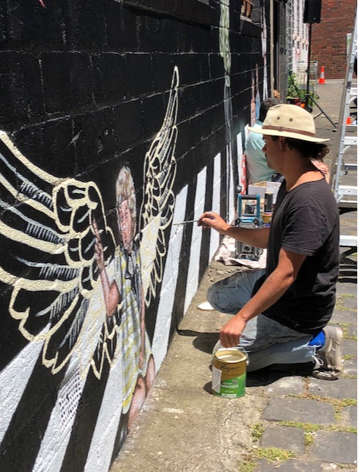

Council-supported mural by Liam Vear in George Street, South Melbourne

### Our partners

**To achieve meaningful improvements in the management of graffiti in our City, Council needs to work in partnership with others. Our residents, traders, the Victorian Government, Victoria Police, neighbouring councils, transport providers and utilities suppliers will all play a crucial role.**

Council values the support of our partners in helping us deliver outcomes outlined within the Plan, as we recognise we can’t achieve them alone. Some of the most significant improvements will rely on leveraging relationships with partners and working together to deliver outcomes. For example, a collaborative approach to graffiti removal in our City will require support from the Victorian Government as well as transport providers and utilities suppliers.

#### Council’s role

* Trusted service provider – Providing high quality graffiti removal services, education and engagement programs to our community in order to achieve our priority outcomes in graffiti management.
* Trusted partner – Advocating and building partnerships with State, Federal and local government agencies, as well as commercial traders and community groups to deliver better outcomes for our community.
* Trusted steward – Investigating new ways of improving services and maintaining our infrastructure and public spaces for our community.
* Monitoring and reporting – Checking in regularly on our progress to ensure we are on track to reach our goals.

#### Community’s role

* Residents – Ensuring that they report graffiti to their property and reduce the likelihood of future graffiti hits by employing CPTED principles to their homes.
* Traders – Reporting graffiti to their property and considering graffiti mitigation techniques. Where applicable, reducing accessibility of graffiti writing products for illegal uses.
* Developers – Engaging with CPTED principles for all new buildings to reduce likelihood of graffiti. Also considering the use of approriate hoarding to minimise graffiti during the construction process.

#### Stakeholder agencies

* Victoria Police / Department of Justice – Working alongside Council in sharing information to increase the apprehension of offenders.
* Utilities Suppliers / Transport Providers/ Government agencies – Elevating their response and prioritisation of graffiti removal in our cities, and working alongside Council to achieve this.

## How we’ll get there

Within this section, Council has set out determined policy outcomes informed by community consultation, evaluation of graffiti statistics in our City and engaging with graffiti management stakeholders and experts in the field.

### Outcome 1: Trusted service levels

#### Offensive and / or obscene graffiti

Council will prioritise the removal of any graffiti deemed offensive and / or obscene. This includes any marking that is defamatory or degrading about race, region, sexual preference and gender, or that releases unwarranted details relating to personal privacy. Graffiti of this nature will be removed within four hours of notification.

#### Precinct spaces and public amenities

Council will prioritise the removal of graffiti from our network of public toilets by way of a dedicated patrol service. The patrol service will aim to monitor and remove graffiti at each site on a weekly basis.

Council will facilitate swifter action on graffiti within precinct spaces by issuing coordinated notices whereby graffiti removal services are opted out of as opposed to being opted into. This action will be enacted at the following locations:

* Acland Street and Fitzroy Street, St Kilda
* Bay Street, Port Melbourne
* Carlisle Street, Balaclava
* Clarendon Street, South Melbourne
* Tennyson Street, Elwood.

#### Standard service levels

Council will support the following graffiti removal services in our City:

* remove graffiti to Council assets and private property
* act on graffiti removal requests within 5-10 business days
* offer alternatives to the graffiti removal services, including graffiti removal kits that can be collected by our community from any of our three town hall locations
* ensure removal of graffiti is consistent with heritage conservation principles.

Council will not support the following:

* the removal of graffiti to locations with limited passive surveillance, such as vacant property or property under construction
* the removal of graffiti above three metres from the ground, or where such removal risks damage to the property or the environment, or the safety of the removal contractor.

### Outcome 2: Ease of access for services offered

**We will leverage new technologies to streamline reporting processes for our community, and will actively communicate services offered.**

#### Improving customer experience

Council will work with property owners and occupiers to secure permissions to remove any reported graffiti in a timely and straightforward manner.

Council will engage the community in understanding and responding to graffiti. Council will offer advice to our community on CPTED principles and how they might take action to reduce graffiti in their neighbourhood.

Council will continue to strive for operational improvements in supporting our community reporting graffiti. This will include, but not be limited to, enhancements to web-based reporting.

##### Case study: Online consent forms

###### Improving access to reporting tools and provision of consent for our community

Consent to remove graffiti on private property can now be completed online. Our community is now able to report and consent to Council cleaning services at their property, business or residence via an online form that can be found on Council’s dedicated [graffiti removal page](http://www.portphillip.vic.gov.au/graffiti_removal.htm).

Making the form available online speeds up the process of gathering consent to remove graffiti   
(a legislative requirement) and makes it easier for our community to engage Council services.   
The online form is accessible on PCs, tablets and mobile phones.

###### How you can play your part

Report graffiti at your own property by using Council’s online graffiti removal consent form.

### Outcome 3: Improvements in liveability

**The City of Port Phillip is an energetically creative place, welcoming and alive with activity. Council will harness this spirit and ensure that our community benefits from improvements in liveability achieved not only through graffiti removal, but also as a result of a wide range of engagement and mitigation techniques.**

#### Graffiti mitigation

In the 2018/19 financial year, Council committed $60,000 to the Graffiti Mitigation Through Street Art Program, and will continue to fund this program in 2019/20.

Council will support and engage with community groups on pursuing grants to fund approriate graffiti mitigation programs. These programs will aim to use a range of approaches to reduce graffiti including: greening, landscaping, community strengthening and art-based interventions.

Council will work collaboratively with a range of internal and external stakeholders to deliver place based programs to break the cycle of persistent graffiti in targeted areas.

**Targets:** Council will commit to the following graffiti mitigation programs to be delivered annually:

* six street art projects
* one greening program.

##### Case study: Little Grey Street

**The use of broad programming to improve outcomes for our community**

In April 2018, Council commenced a program of graffiti removal in Little Grey Street, in response to a community safety audit held in March 2018.

The program approached the persistent graffiti in this space in a holistic and coordinated manner, and aimed to stagger Council’s response to deliver a successful outcome without impacting on graffiti removal service levels to the wider community. Accordingly, over a period of five months Council completed the removal works, which has enabled maintenance contractors to act quickly and efficiently to any graffiti re-hits in the area.

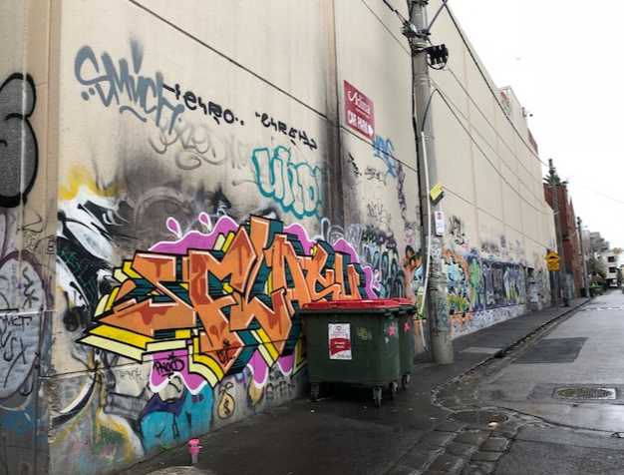 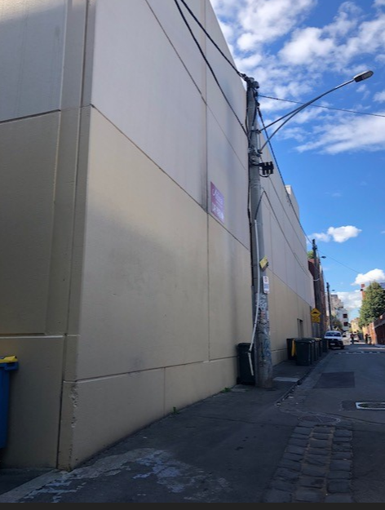 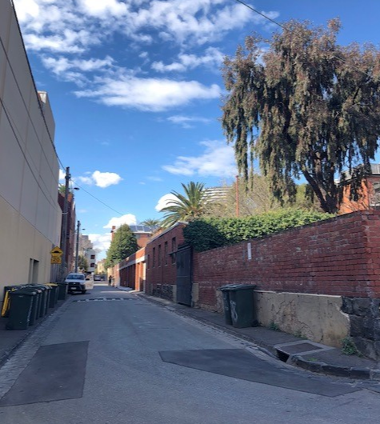

Before After

Council has continued to work alongside local residents to ensure any new graffiti is removed, to break the cycle and eradicate graffiti in this space.

In conjunction with this graffiti removal program, Council has concurrently worked towards a greening graffiti mitigation project in the adjacent Dalgety Street Reserve. This project has been funded by the Victorian Government’s Community Crime Prevention Program.

Council has worked alongside local residents to develop a community garden that aims to increase passive surveillance in and around the area, as well as strengthening community relationships. Following consultation, the gardens will be installed with the support of local residents who will act as custodians of the gardens.

By addressing graffiti at this location using a multifaceted approach, Council has significantly reduced graffiti in the area and improved liveability.

### Outcome 4: Collaboration with partners and our community

**To make a big impact on managing graffiti we will need to engage the support of our community and agency partners to ensure our responses are coordinated and meaningful.**

#### Capacity development and empowerment

Council wil support activities to deliver education initiatives to our community on graffiti issues, including, but not limited to, the provision of graffiti kits and demonstrations as to their use, as well as provision of site based advice on how home and business owners might take action to mitigate against graffiti at their properties.

Council will consider CPTED principles in mitigating against graffiti when managing, maintaining and developing existing and new assets. This will include, but not be limited to: investigating uses and benefits of anti-graffiti coatings, paint and cladding, the integration of murals and appropriate choices in urban and product design.

**Targets:** Council will commit to the following community education and engagement events to be delivered annually:

* Quarterly community events dedicated to communicating Council’s services to our community and engaging our community on how they can reduce the impact of graffiti in their neighbourhood.

#### Advocating for a collaborative approach

Council will advocate for improved responses in graffiti removal from utilities suppliers and transport providers, and will continue to work alongside other government agencies in taking action against graffiti.

Council will continue to be an active partner within state and local forums and graffiti working groups, with such actions including Council’s support of the newly inaugurated Victoria Graffiti Register.

##### Case study: Collaborative graffiti mitigation projects with utilities suppliers

**Leveraging partnerships to deliver collaborative outcomes with greater reach and impact**

In 2018, Council worked alongside Citipower and VicRoads to deliver a collaborative street art program focused on transforming street assets along the southern end of Fitzroy Street in St Kilda. The program was funded by the asset owners and delivered in conjunction with Council’s Arts team, who engaged the artist duo Creature Creature to paint nine units along the street.

Delivering holistic graffiti removal in our City is challenging due in part to the differing ownerships and responsibilities involved. For example, publicly owned assets are the responsibility of the asset owners to maintain. However, service levels offered by the asset owner to mainten their assets are often significantly lower than the service levels offered to our community by Council. Our community has told us that the look and feel of our City often suffers as a result.

Council has worked hard to improve relationships with utilities suppliers, transport providers and other government agencies servicing our City, in order to improve outcomes for our community. This program is an example of the collaboration in practice. Since the artwork was installed, there has been only one instance of graffiti to the units, which was quickly and easily removed thanks to an anti-graffiti coating used to protect the integrity of the treatment.

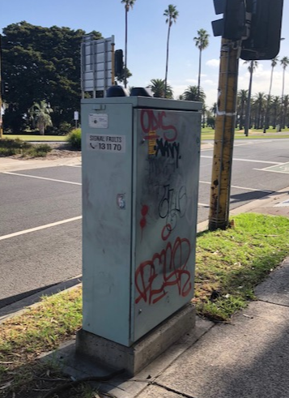 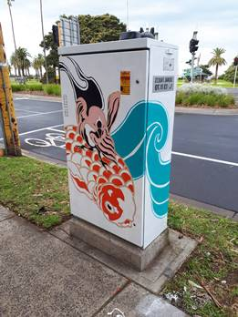

Fitzroy Street, VicRoads Signal Box - Before Fitzroy Street, VicRoads Signal Box - After

#### Advocating for state and federal funding to assist with collaborative outcomes

Council hopes to deliver similar graffiti mitigation projects in the future, and will work with partner agencies to improve both the mitigation and removal of graffiti on assets. This work will be possible thanks to the recent securing of funds from the Victorian Government’s Department of Treasury, via their Community Support Fund (a joint venture of the Inner South Metropolitan Mayors Forum), and demonstrates the success of working collaboratively alongside our partners.

Funds will support a pilot program to enter into collaborative arrangements with select utilities suppliers and transport providers whereby Council will remove and mitigate against graffiti incurred to their public assets on their behalf. It is anticipated that this program will include the following asset types: road signage, traffic signals, power boxes, substations and accessible rail underpasses.

This two year pilot program will not only deliver immediate results in our City, but will also allow Council to secure a data set and program evaluation results. These will be used to further advocate to the Victorian Government for an ongoing future program. Council aims to leverage significant and lasting solutions as a result of the trial.

### Outcome 5: Evaluation and measuring of success

**Council will set measureable targets to ensure that our graffiti management plan is trusted, achievable and on track to deliver outcomes.**

Council will actively monitor the efficacy of its graffiti management plan. Monitoring will be evidenced and reviewed by data captured as part of the graffiti removal program. Council has set contract level KPIs for the graffiti removal contract, and will continue to monitor the success of these KPIs to deliver the best service to our community.

Data captured through the graffiti removal program will support the development of, and planning for, migitation activities and programs. The regular review of data will also allow for reallocation of resources if deemed appropriate and within operational capacity. Council has set the following targets within this Plan for graffiti mitigation programs, which will be monitored on an annual basis to measure ongoing success:

#### Graffiti mitigation targets

Council will commit to the following mitigation programs to be delivered annually:

* six street art projects
* one greening program.

Council will continue to research and enact best practice principles in graffiti management as knowledge in this arena progresses. Council will ensure they communicate our services and best practice in graffiti management at all available opportunities. To measure this success, Council has set out the below targets within this Plan for community outreach opportunities:

##### Capacity Development Targets:

Council will commit to quarterly community events dedicated to communicating Council’s services to our community and engaging our community on how they can reduce the impact of graffiti in their neighbourhood. These community education and engagement events are to be delivered annually.

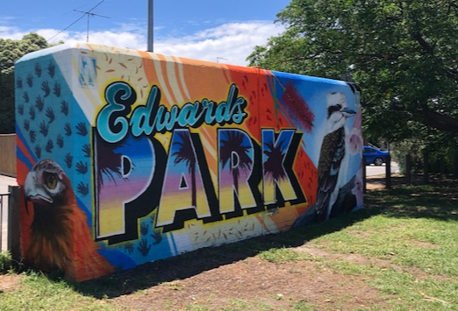

Edwards Park Art Project, supported by the Victorian Government’s Community Crime Prevention *Program*

## Acknowledgements

The City of Port Phillip’s Maintenance and Operations, Cultural and Economic Development, Diversity and Inclusion, Future Comunities, Placemaking, Open Space and Recreation Services, Customer Experience and Transformation, Place and Design, and Family, Youth and Children departments have all provided input into the Plan.

The cities of: Banyule, Bayside, Bundoora, Casey, Darebin, Geelong, Glen Eira, Maribyrnong, Melbourne, Melton, Stonnington and Yarra have all been consulted in the development of the Plan.

Thanks to: Sean Ling (Department of Justice), Christine Newman (Department of Justice),   
Jeffrey Smith (Department of Health & Human Services), Inspector Jason Kelly (Victoria Police), Senior Sargent Ingrid Ebert (Victoria Police), John Hennessy (Municipal Association of Victoria), Danielle McCaffrey (StarHealth) and Kate Kelly (Port Melbourne Neighbourhood Centre).

Thank you also to the members of our community who provided us with their feedback and thoughts as part of the community consultation process.

## Related documents and attachments

An Implementation Action Plan is attached, and provides a framework within which Council can prioritise and develop outlined strategies within the itemised time frames.

Associated Council plans, strategies and groups include:

* Art and Soul - Creative and Prosperous City Strategy 2018-22
* Asset Management Policy 2017
* Community Safety Plan
* Cultural Heritage Reference Committee
* Don’t Waste It! Waste Management Strategy 2018-28
* Greening Port Phillip
* Health and Wellbeing Implementation Strategy 2017-21
* Public Space Strategy (in development).

## Graffiti management - Five year Implementation Action Plan 2019-24

### Outcome 1: Trusted service levels

| Outcome | Year | | | | | Partners | Resource |
| --- | --- | --- | --- | --- | --- | --- | --- |
| 1 | 2 | 3 | 4 | 5 |
|  |  |  |  |  |
| 1.1 Remove offensive and / or obscene graffiti within four hours of notification | Implemented and ongoing | | | | | Community, contractors | Existing |
| 1.2 Action graffiti removal requests within 5-10 business days | Implemented and ongoing | | | | | Community, contractors | Existing |
| 1.3 Remove graffiti from Council-owned signs, furniture and bins within 10 business days | Implemented and ongoing | | | | | Community, contractors | Existing |
| 1.4 Program a patrol lead graffiti removal to Council owned public toilets – with each being checked on a weekly basis | Planning | Implemented and ongoing | | | | Community, contractors | New |
| 1.5 Issue annual opt out notices at defined precinct locations and subsequently enact planned graffiti removal in these spaces | Planning | Implemented and ongoing | | | | Community, contractors, traders associations | Existing |
| 1.6 Provide free graffiti removal kits to our community on request | Implemented and ongoing | | | | | Community, traders associations | Existing |
| ­1.7 Review Council’s graffiti removal contract every three years, renewing as appropriate through a competitive tender process | Implemented and ongoing | | | | | Contractors | Existing |
| 1.8 Investigate new and sustainable technologies to support graffiti removal | Implemented and ongoing | | | | | Local government, industry experts | Existing |

### Outcome 2: Ease of access for services offered

| Outcome | Year | | | | | Partners | Resource |
| --- | --- | --- | --- | --- | --- | --- | --- |
| 1 | 2 | 3 | 4 | 5 |
|  |  |  |  |  |
| 2.1 Communicate the services offered by Council in relation to graffiti management widely and via multiple mediums | Implemented and ongoing | | | | | Community, traders associations | Existing |
| 2.2 Proactively contact property owners and occupiers in sselected precinct locations advising them of services offered | Planning | Implemented and ongoing | | | | Community, traders associations | Existing |
| 2.3 Monitor ongoing graffiti in precinct spaces and take proactive action on removal | Planning | Implemented and ongoing | | | | Community, traders associations | Existing |
| 2.4 Develop improvements to Council website and online presence for graffiti | Planning | | Implemented and ongoing | | |  | Existing |
| 2.5 Develop a social media campaign and presence to promote Council’s graffiti services | Planning | | Implemented and ongoing | | |  | Existing |
| 2.6 Participate in the development and delivery of the cross council/ agency Victorian Graffiti Register for use as a reporting and tracking tool | Planning | Implemented and ongoing | | | | Department of Justice, Local government, Victorian government agencies, Victoria Police | Existing |
| 2.7 Ensure information posted on Council’s website in relation to graffiti management and services is kept updated | Implemented and ongoing | | | | |  | Existing |
| 2.8 Leverage new technologies in continuing to improve ways that our community can report graffiti | Planning | | | Implemented and ongoing | | Community, Department of Justice, Industry experts, Victorian government agencies, Victoria Police | New |

### Outcome 3: Improvements in Liveability

| Outcome | Year | | | | | Partners | Resource |
| --- | --- | --- | --- | --- | --- | --- | --- |
| 1 | 2 | 3 | 4 | 5 |
|  |  |  |  |  |
| 3.1 Invest in an ongoing street art program to mitigate against graffiti at known hot spots | Implemented and ongoing | | | | | Community, Developers, Traders associations, Transport Providers, Utilities suppliers, Victorian government agencies | Existing |
| 3.2 Explore best practice in preserving legitimate street art and reducing future tagging | Implemented and ongoing | | | | | Industry experts, Local governement, Victorian government agencies, Victoria Police | Existing |
| 3.3 Consult with community and community groups to develop strategies and programs to mitigate against graffiti at known and emerging hotspots | Implemented and ongoing | | | | | Community, Traders associations | Existing |
| 3.4 Encourage alternative treatments on public assets such as post boxes and traffic signal boxes to reduce the impact of graffiti on our streets | Advocacy | Planning | Implemented and ongoing | | | Transport providers, Utilities suppliers, Victorian government agencies | New |
| 3.5 Seek out partnerships with local community groups to support graffiti mitigation programs and the securing of associated grant funding | Implemented and ongoing | | | | | Community, Federal government, Traders associations, Victorian government agencies | Existing |
| 3.6 Investigating uses and benefits of anti-graffiti coatings, paint and cladding, the integration of murals and appropriate choices in urban and product design and development | Planning | | | Implemented and ongoing | | Contractors, Industry experts, Local government | Existing |
| 3.7 Deliver place based solutions to graffiti issues in precinct locations | Planning | Implemented and ongoing | | | | Community, Traders associations, Transport providers, Utilities suppliers | New |

### Outcome 4: Collaboration with partners and our community

| Outcome | Year | | | | | Partners | Resource |
| --- | --- | --- | --- | --- | --- | --- | --- |
| 1 | 2 | 3 | 4 | 5 |
|  |  |  |  |  |
| 4.1 Deliver opportunities to engage with our community and promote graffiti management services as well as providing advice on CPTED principles and other ways in which property owners and occupiers can reduce impacts of graffiti. | Implemented and ongoing | | | | | Community, Traders associations | Existing |
| 4.2 Carry out education programs on graffiti and graffiti management | Implemented and ongoing | | | | | Community, Traders associations | Existing |
| 4.3 Seek out and connect local partners to develop ongoing programs that both improve community wellness and act to reduce graffiti | Implemented and ongoing | | | | | Community, Traders associations, Victorian government agencies | Existing |
| 4.4 Continue to engage actively in state forums and working groups to share information and advocate for improve cohesion in state graffiti management | Implemented and ongoing | | | | | Department of Justice, Federal government, Local government, Victorian government agencies, Victoria Police | Existing |
| 4.5 Work alongside utilities suppliers and transport providers to support improved services to graffiti removal on their assets in the City | Advocacy | Planning | Implemented and ongoing | | | Transport providers, Utilities suppliers | New |
| 4.6 Advocate for funding opportunities for collaborative programs in graffiti removal | Advocacy | | | | | Department of Justice, Federal government, Local government, Victorian government agencies | Existing |

### Outcome 5: Evaluation and measuring of success

| Outcome | Year | | | | | Partners | Resource |
| --- | --- | --- | --- | --- | --- | --- | --- |
| 1 | 2 | 3 | 4 | 5 |
|  |  |  |  |  |
| 5.1 Ensure all projects and programs delivered have sufficient evaluation and monitoring put in place to measure success | Implemented and ongoing | | | | |  | Existing |
| 5.2 Conduct regular auditing of graffiti removal contract to ensure services are to standard – checking that KPI’s are met | Implemented and ongoing | | | | |  | Existing |
| 5.3 Investigate the introduction of tracking graffiti trends by mapping using geodata | Planning | | | Implemented and ongoing | | Industry experts | New |
| 5.4 Conduct annual reviews of the data collected as a result of the graffiti removal contract and monitor the graffiti management plan and its ongoing efficacy against this information | Implemented and ongoing | | | | |  | Existing |
| 5.5 Ensure that targets set within the Plan are met or exceeded on an annual basis | Implemented and ongoing | | | | |  | Existing |